|  |  |  |  |  |  |  |  |  |
| --- | --- | --- | --- | --- | --- | --- | --- | --- |
|  | | | | | | | | |
|  | | The Book House | | | | |  | |
|  |  | | | | | | |  |
|  | | | |  |  | | | |
|  | | | | This document will provide the Overview of the Project along with the outline of the DevOps tools. |  | | | |
|  | | | | —DevOps—Vimala Devi G |  | | | |
|  | | |  | | |  | | |

Index:

|  |  |
| --- | --- |
| S.NO | Topic |
| 01 | Introduction |
| 02 | Pre-requisites |
| 03 | DevOps Tools |
| 04 | Dockers |
| 05 | Kubernetes |
| 06 | Monitoring |
| 07 | Summary |

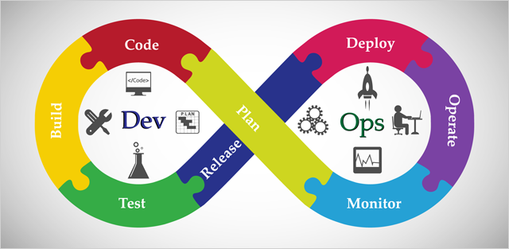

**Introduction:**

This Document represents the project of the Book House app which is hosted on a Tomcat server by using container architecture with Dockers. The complete infrastructure is hosted on Azure (used Free Subscription for Demo).

**Prerequisites:**

1. Azure Subscription
2. GitHub Account
3. Knowledge of Linux
4. Knowledge of basic DevOps Tools such as
   1. GIT
   2. Maven
   3. Jenkins
5. Azure Monitor (VM Insights, App Insights, Container Insights)
6. Four Linux VMs (4*32)
7. Docker Hub Account

**DevOps Tools:**

Tools Overview:

|  |  |
| --- | --- |
| Tools | Usage |
| **Azure** | **Cloud Platform** |
| **Apache Tomcat** | **Web and App server** |
| **MySQL** | **DB** |
| **Git Hub** | **Version Control** |
| **CI/CD** | **Jenkins** |
| **Maven** | **Build Tool** |
| **Dockers and Kubernetes** | **Containerization** |
| **IaC** | **Terraform** |
| **Monitoring** | **Azure Monitor and Grafana** |

***GIT for Version Control:***

In this Project, we have used GIT for Version controlling from where we can pull the code and track the versions of the code alone with the change history. Here we have used distributed version controlling of GIT.

How can we Pull the code from GITHUB?

We have many ways to pull the code from the GITHUB, but in this project, we have used the Fork method to fetch the code from One to Other account as explained below:

1. Explore the code in GITHUB and choose the correct application code as per your requirements and click on Fork.

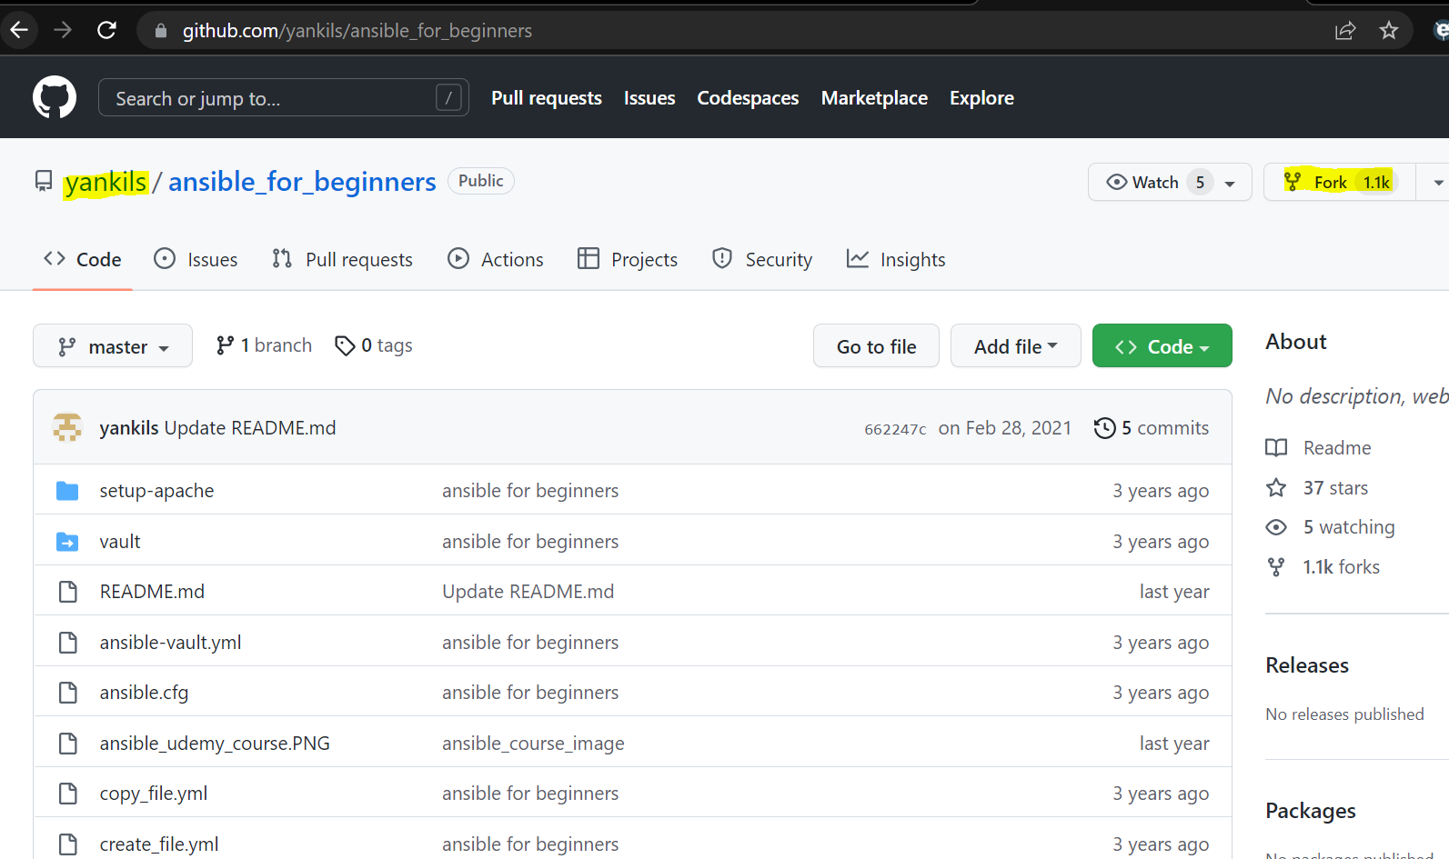

1. It will navigate you to the Fork creation page where we must mention our GIT username and we can change the repository name if needed and click on Create Fork

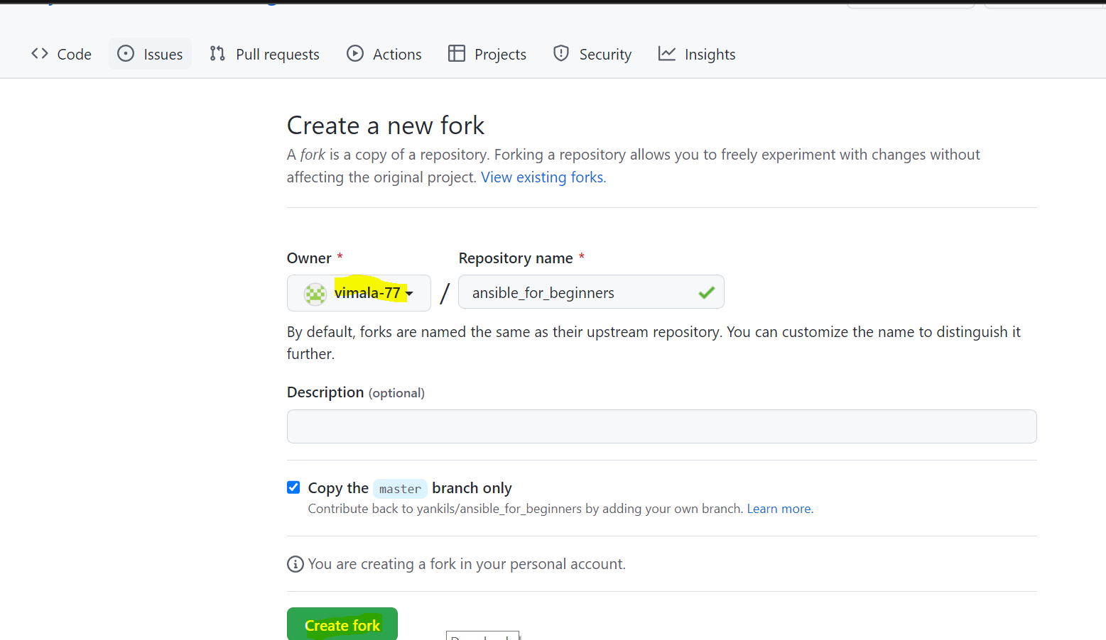

1. Post clicking on the fork the complete repository will we pulled to your GIT Hub account.

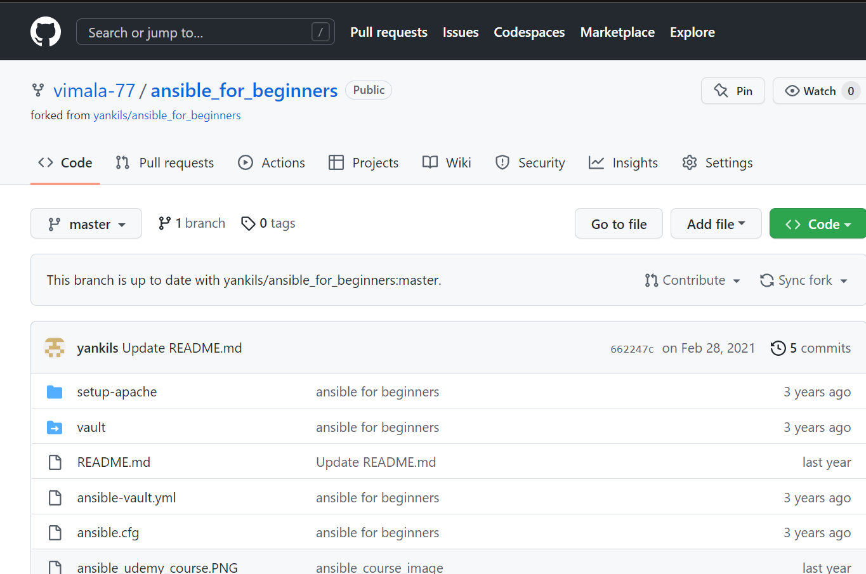

Other Methods Which we have explored.

1. We can install GIT in our server and use git clone command to pull the complete repository.

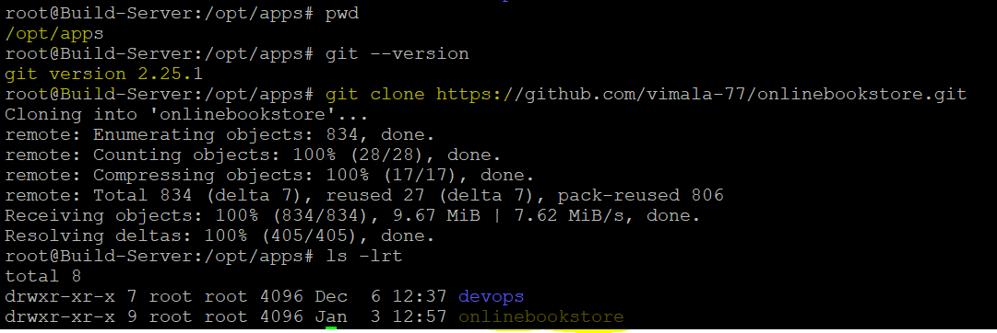

1. We can download the code as a ZIP file from GitHub and integrate it with VSCode and push that code to your account using a few git commands

|  |
| --- |
| g*it init 🡪 creates a .git file*  *git status 🡪 shows the unstaged files*  *git add . 🡪 to add the files to the stage*  *git commit -m “commit message” 🡪 to commit the changes*  *git remote add origin* [*https://github.com/vimala-77/devops.git*](https://github.com/vimala-77/devops.git) *🡪 to add the project to GIT*  *git push -u origin master* |

1. We can also use Jenkins to pull and push the code to our servers.

***Maven as a Build Tool:***

We have used Maven to build an artifact(.war/.ear) from our source code.

Prerequisites:

1. Azure VM as a build server
2. Java should be available

Installation of Maven(mvn):

1. Create a VM in azure and install java on it.

|  |
| --- |
| Apt install openjdk-11-jre-headless |

1. Install Maven, We have taken installation instructions from the below link.

<https://www.digitalocean.com/community/tutorials/install-maven-linux-ubuntu>

|  |
| --- |
| cd /opt  wget <https://download.java.net/java/GA/jdk13.0.1/cec27d702aa74d5a8630c65ae61e4305/9/GPL/openjdk-13.0.1_linux-x64_bin.tar.gz>  tar -xvf openjdk-13.0.1_linux-x64_bin.tar.gz  mv apache-maven-3.6.3 maven |

1. Setup the env variables for the maven (M2 Home)

|  |
| --- |
| cd ~  vi .profile  #Add the below values.  M2_HOME=/opt/maven  M2=/opt/maven/bin  JAVA_HOME=/usr/lib/jvm/java-11-openjdk-amd64    PATH=$PATH:$HOME/bin:$JAVA_HOME:$M2_HOME:$M2    export PATH |

Before configuring environment variables:

root@Build-Server:~# echo $PATH

/usr/local/sbin:/usr/local/bin:/usr/sbin:/usr/bin:/sbin:/bin:/usr/games:/usr/local/games:/snap/bin

Post Configuring environment variables:

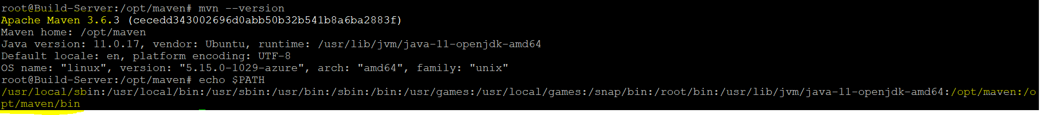

The Two ways of creating a .war file I have explored:

1. Manual Method:

Post installing the maven we must pull the source code using “git clone” , then we have to run the build package command from the directory which has the pom.xml file.

Pom.xml 🡪 In this XML file we will mention all the instructions to build the artifacts. Maven read those instructions and as output, it will give you the .war/.ear packages under the target directory.

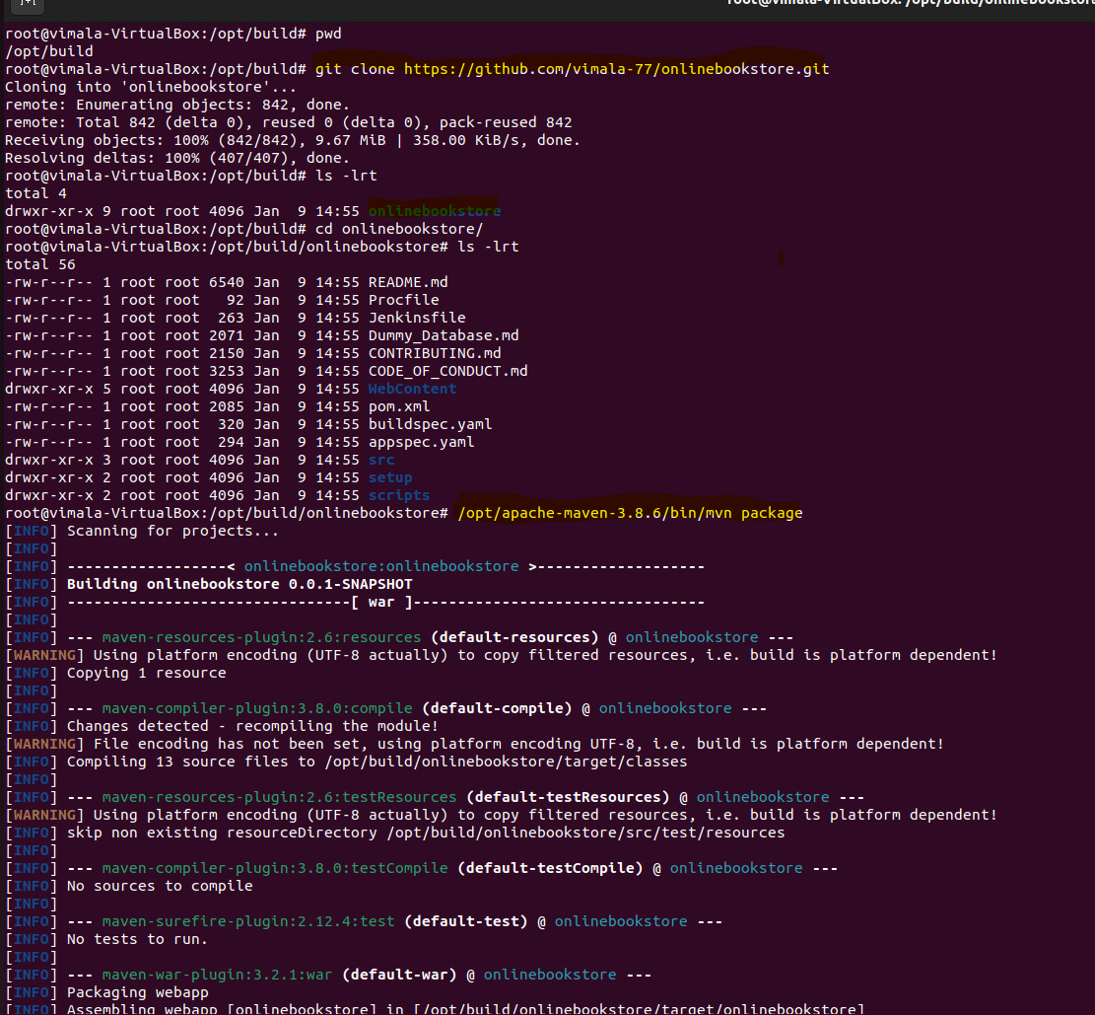

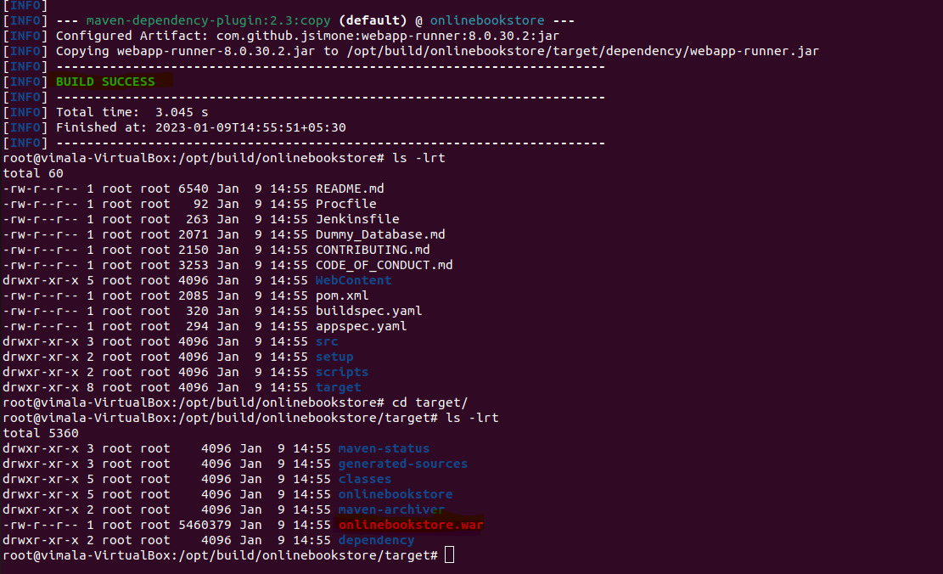

1. Using Jenkins pipeline which will be discussed later in this document.

***Tomcat as a Server:***

We have used Tomcat to host our Book House application. We have installed and tested the tomcat in two way

1. Tradition way/Manually
2. Using Docker Images.

We will discuss the manual installation method here and dockers in the upcoming section of this document.

Manual Installation of Tomcat server:

1. Create a dedicated VM (tomcatapp01) and install java in that VM.
2. Use the below commands for the installation of Tomcat.

|  |
| --- |
| Java -version  apt install openjdk-11-jre-headlesss  cd /opt/  wget <https://dlcdn.apache.org/tomcat/tomcat-9/v9.0.70/bin/apache-tomcat-9.0.70.tar.gz>  tar -xvzf apache-tomcat-9.0.70.tar.gz  mv apache-tomcat-9.0.70 tomcat  cd tomcat/bin/  ./startup.sh 🡪 To start the tomcat |

1. After starting the tomcat, the management console of tomcat should be accessible with an 8080 port.

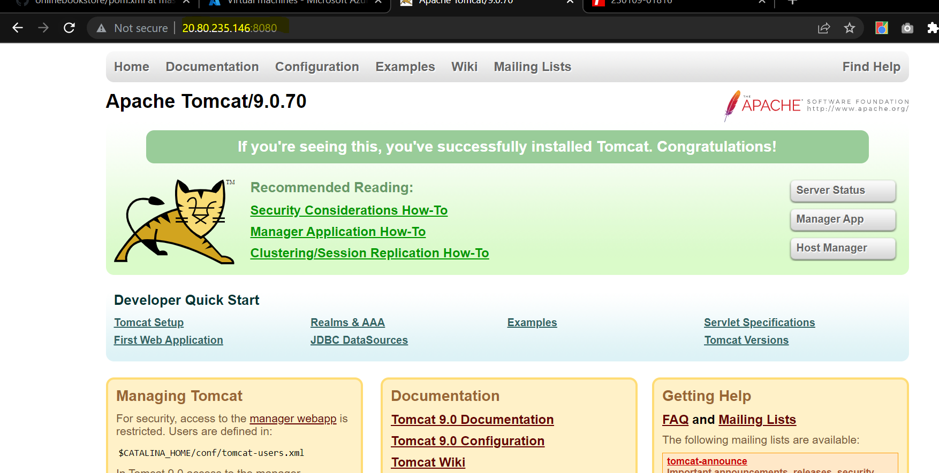

1. But when you click in Manger app on the console it will show 401 error.

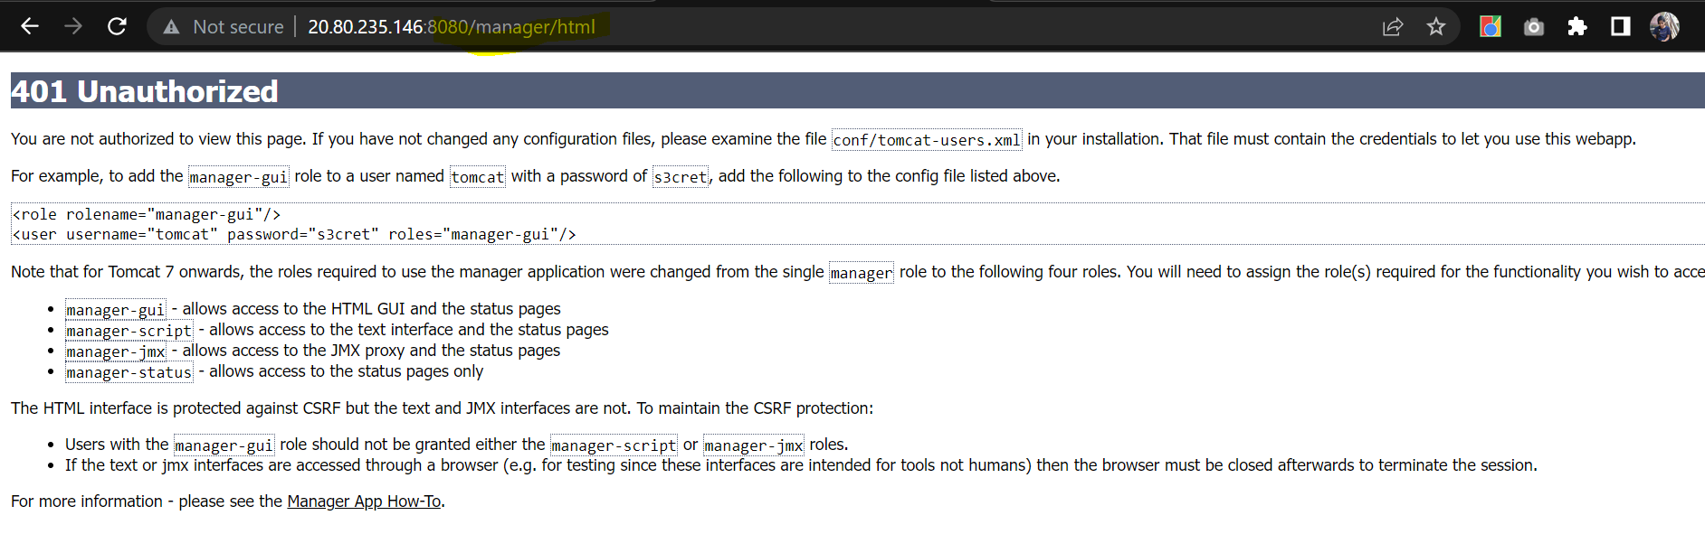

1. To resolve this, we must change the default configuration context.xml and tomcat-user.xml.

Changes in context.xml:

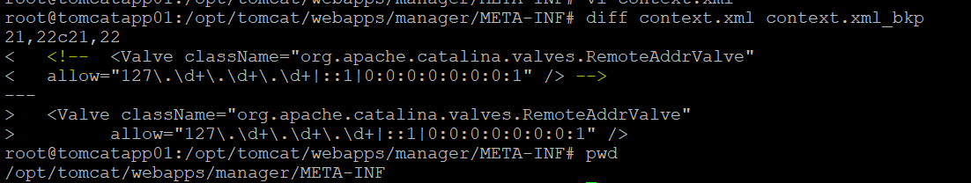

Changes in tomcat-user.xml:

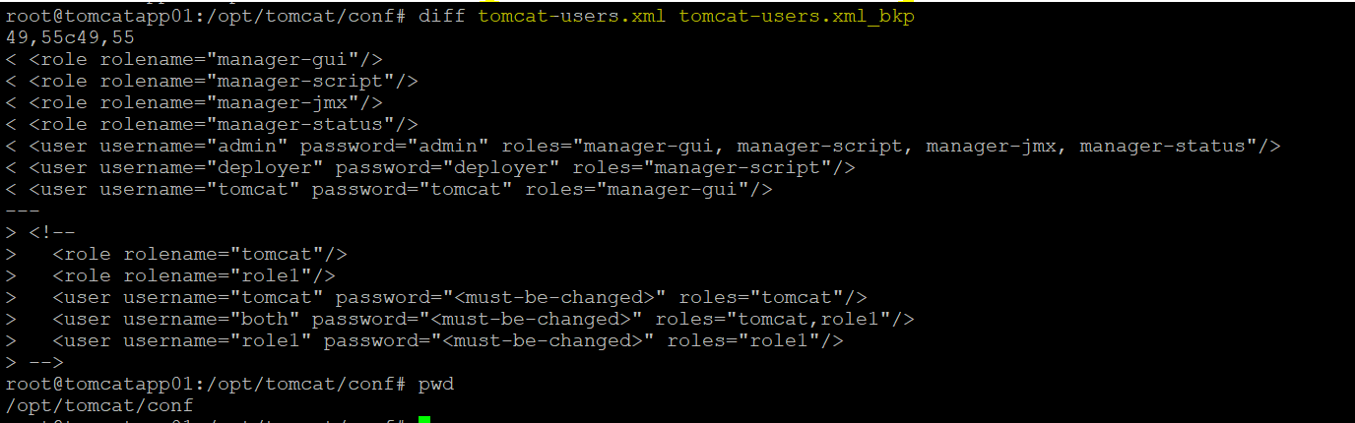

1. After updating both the XML files, we should do the tomcat restart and login with username which we mentioned in the tomca-user.xml

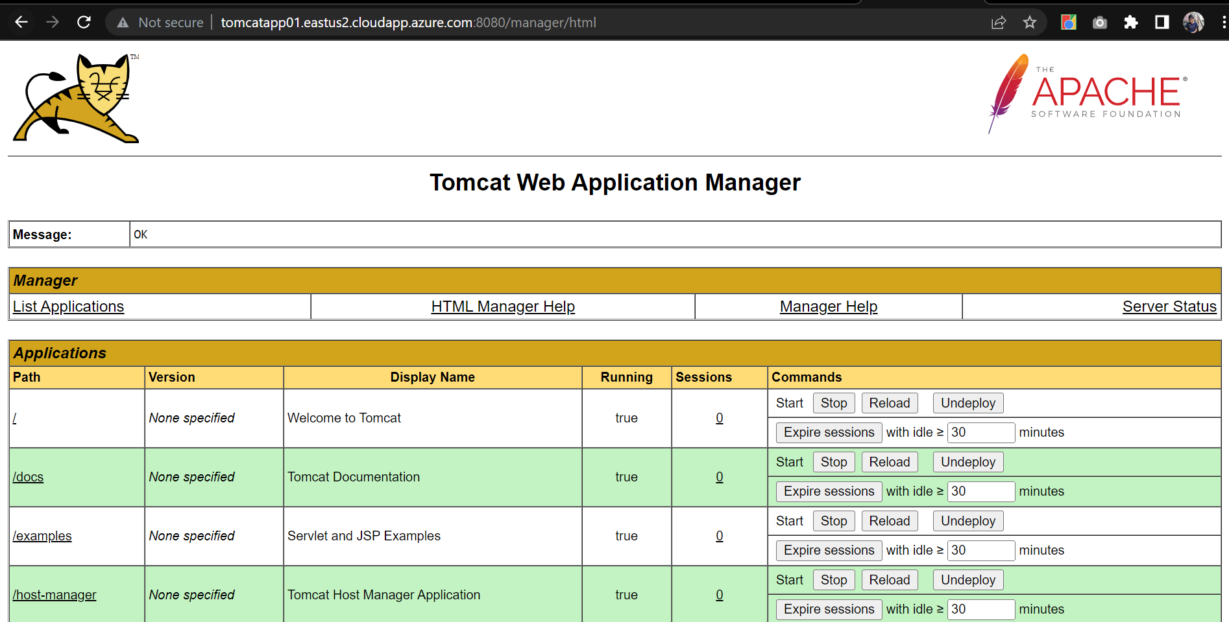

Now the installation of the tomcat is completed we can place the .war file which we have created with the help of Maven under /opt/tomcat/webapps followed by restart then our application will be accessible with <http://tomcatapp01.eastus2.cloudapp.azure.com:8080/onlinebookstore>

But instead of copying .war directly, we will use Jenkins to do our application deployment.

***Jenkins for CI/CD and Automcation:***

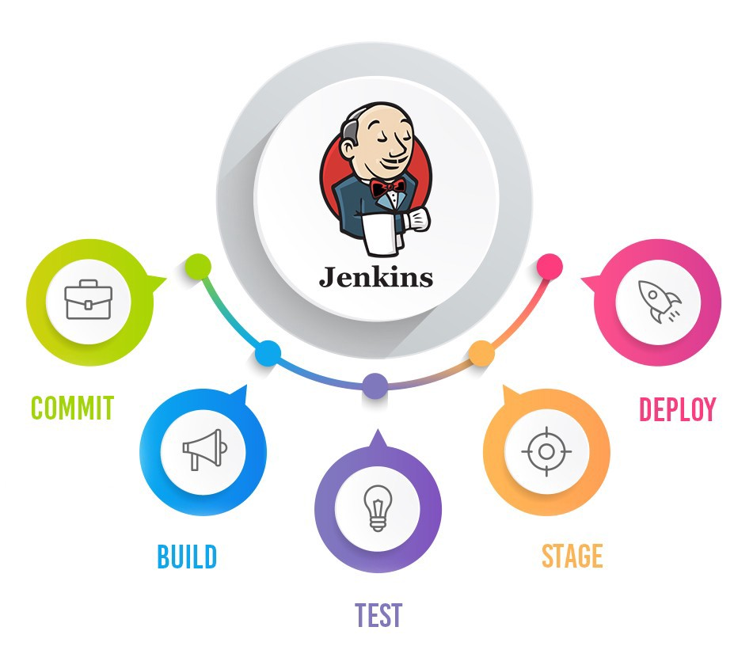

So far, we have seen the manual method of pulling code, build the application, and deploying it in the Tomcat server. Now we will use Jenkins to do those tasks in an automated way by creating a few respective jobs/pipelines.

Let’s see the installation of Jenkins:

Prerequisites:

1. Azure VM (we have created a VM build-server)
2. Availability of Java

Installation:

1. We have installed Jenkins by following the steps mentioned in the page.

<https://pkg.jenkins.io/debian-stable/>



1. Jenkins console can be accessible with port 8080

<http://build-server.centralindia.cloudapp.azure.com:8080/>

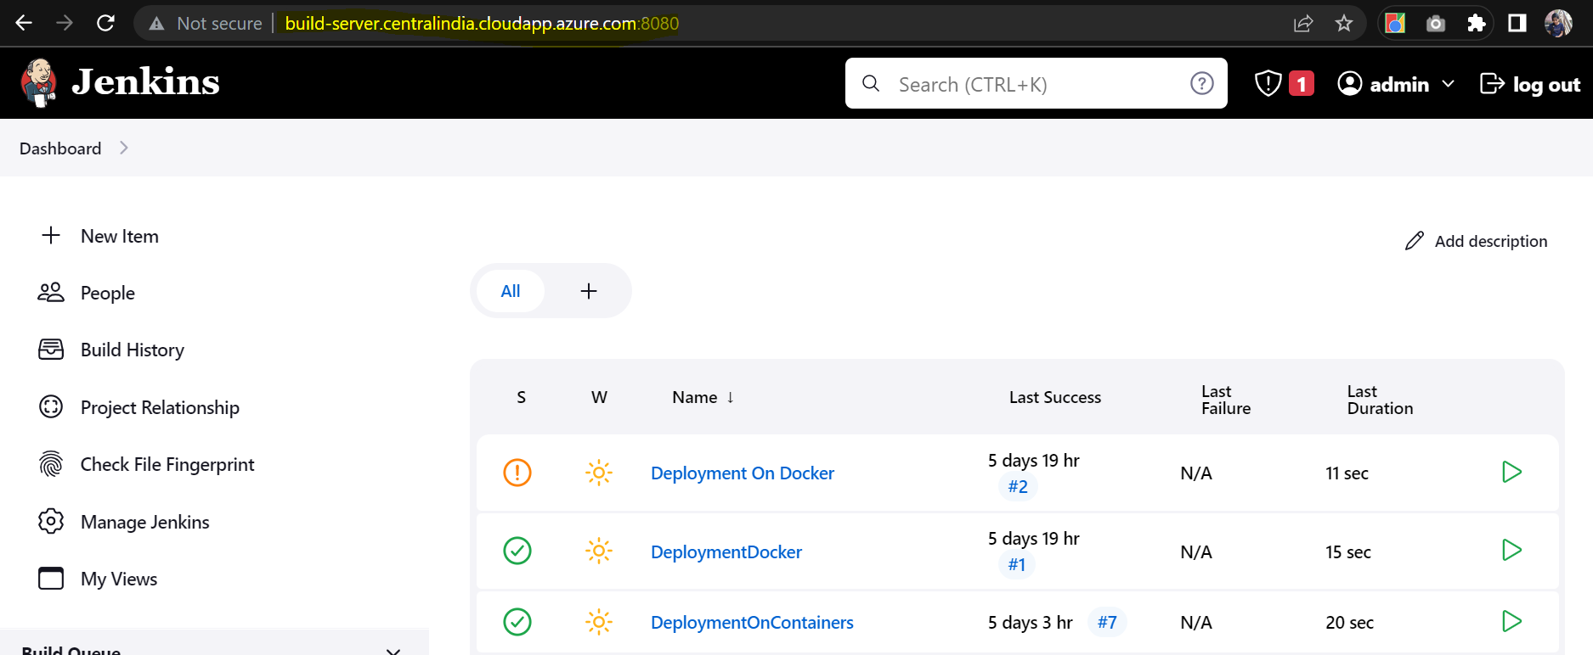

Now as the installation part is completed, we will create Jenkins Jobs to do the below task:

1. Pulling the code for GitHub
2. Creating the artifacts with the help of Maven
3. Deploying the artifacts into the tomcat server.

***Jenkins with GitHub:***

We can use Jenkins to pull the code from GitHub and automate the pipeline so that the job will run whenever we do some code changes.

1. Install GIT in the build server(server which has the Jenkins), installation step as already mentioned above
2. Install GIT Plugin in the Jenkins

Manage Jeniks 🡪 Manage Plugins 🡪Available(search for github) 🡪 Install the plugin

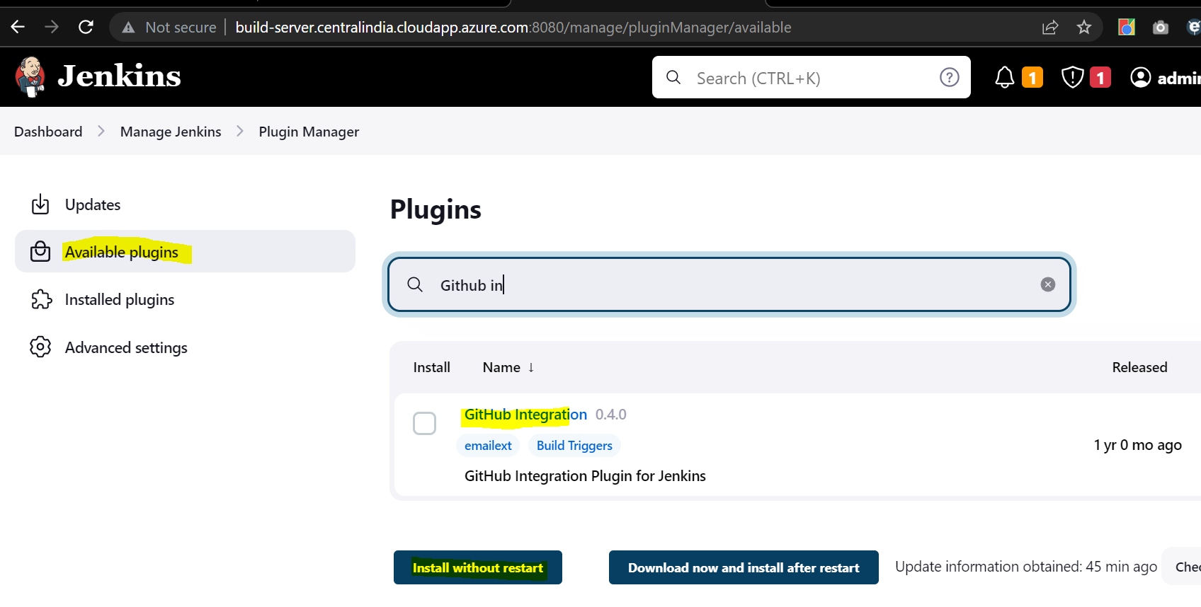

1. Configure the Installed GIT Plugin in the Jenkins

Manage Jenkins 🡪 Global Tool Configuration

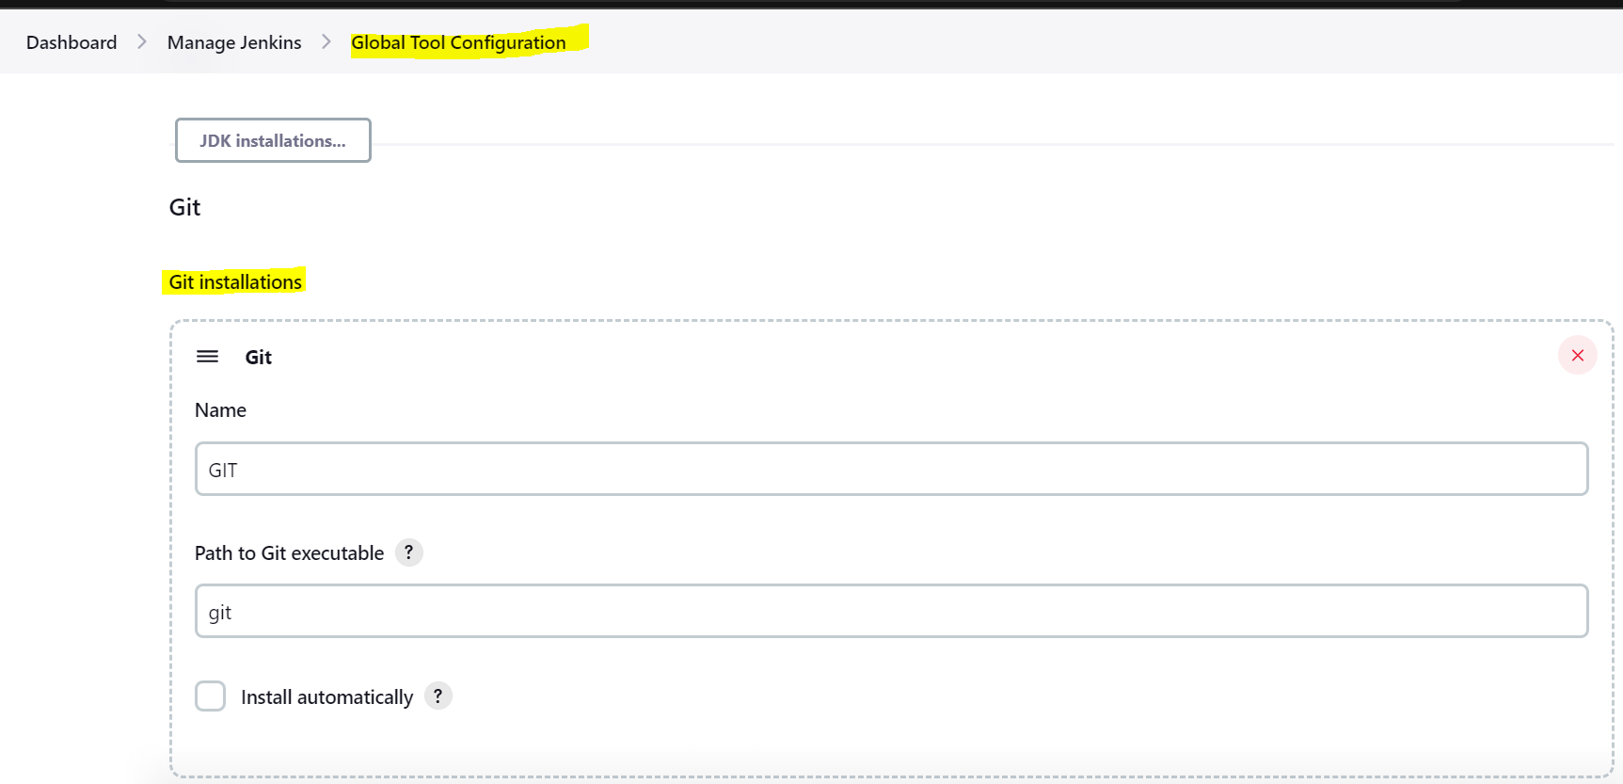

1. Create a Job to pull the code from GitHub to the server.

Dashboard 🡪 New Item 🡪 Give the Pipeline name(CodeFromGitHub)🡪 Choose FreestyleProject 🡪 Under SCM choose GIT and provide the GIT HTTPS url 🡪 Under Branches to Build give the Git Branch from which you want the code.

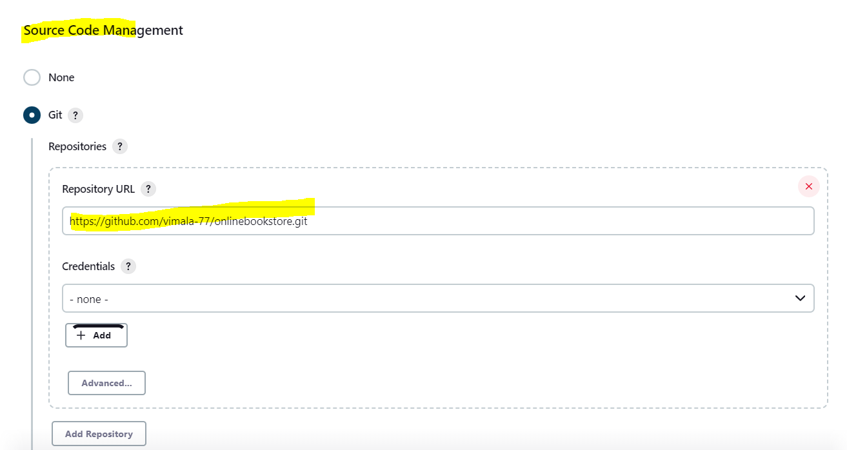

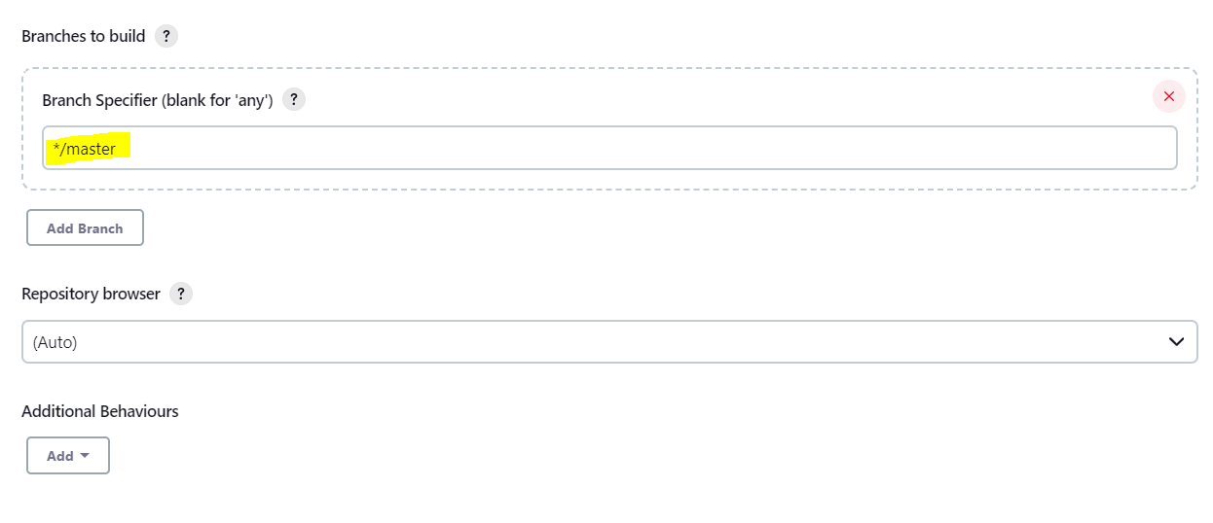

1. After saving this configuration trigger the pipeline by clicking Build now. The build will run and creates a workspace under /var/lib/imala/workspace/CodeFromGitHub along with the code.

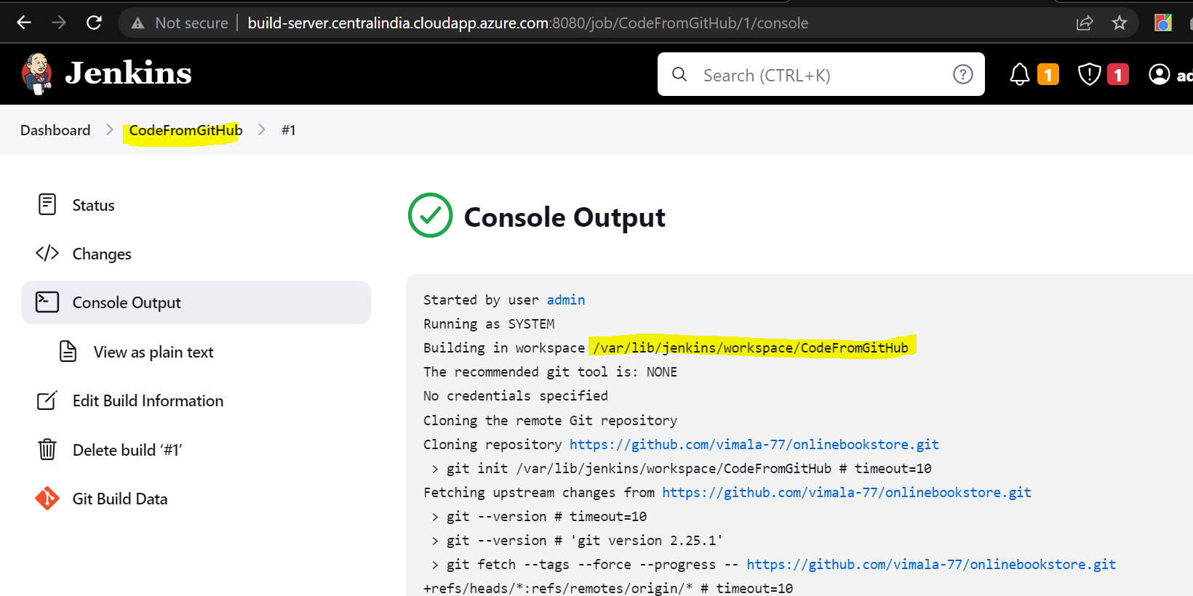

***Jenkins with Maven:***

We have already seen how we can use maven and build our code. Using Jenkins, we can automate things in such a way that when we do the code changes the pipeline will trigger to get the latest code from GIT and it will that code and give us the latest artifacts.

Prerequisites:

1. Java and Maven Installation
2. Setting up the env variables
3. Installation of Maven plugin in Jenkins

We have already mentioned the steps for the installation of Java, and Maven and setting up the env variables. Let’s install the maven plugin in Jenkins

1. Manage Jenkins 🡪 Manage Plugins 🡪Available (search for Maven) 🡪 Install the plugin

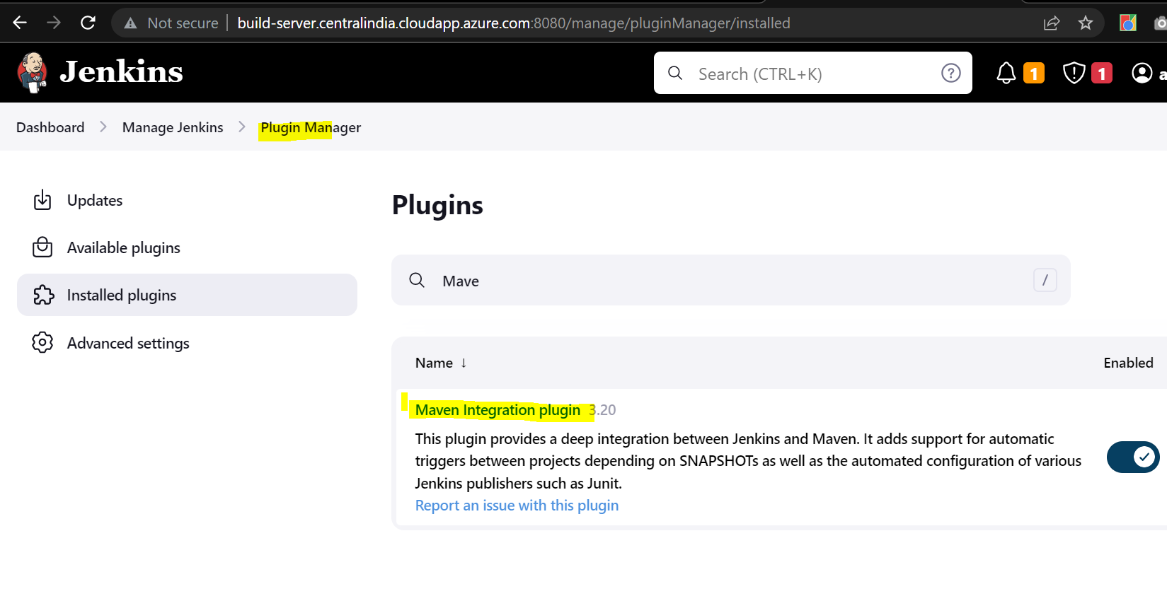

1. Configure the JDK and maven under Global Tool Configuration.

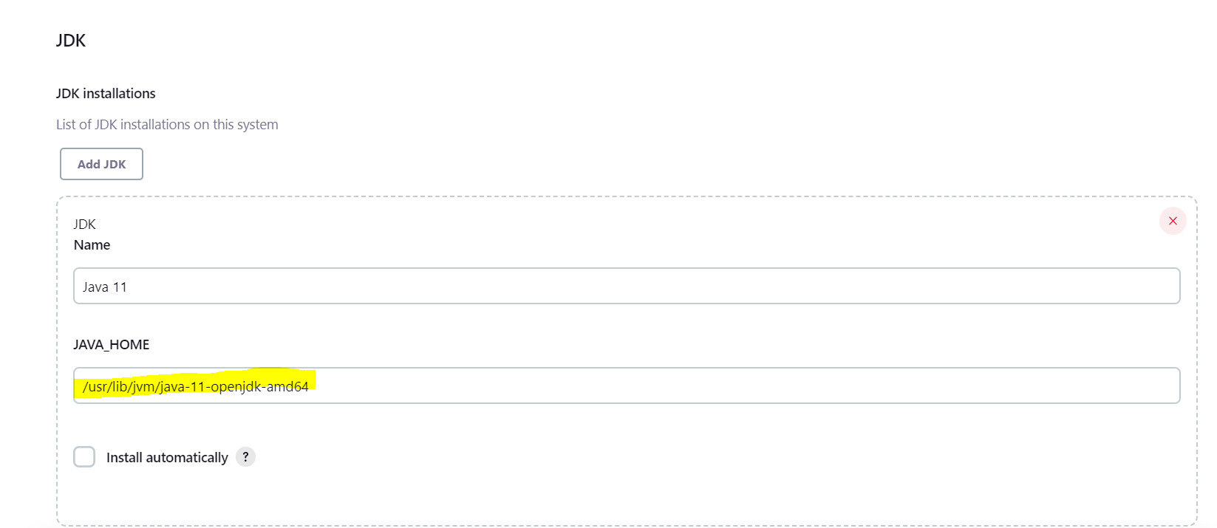

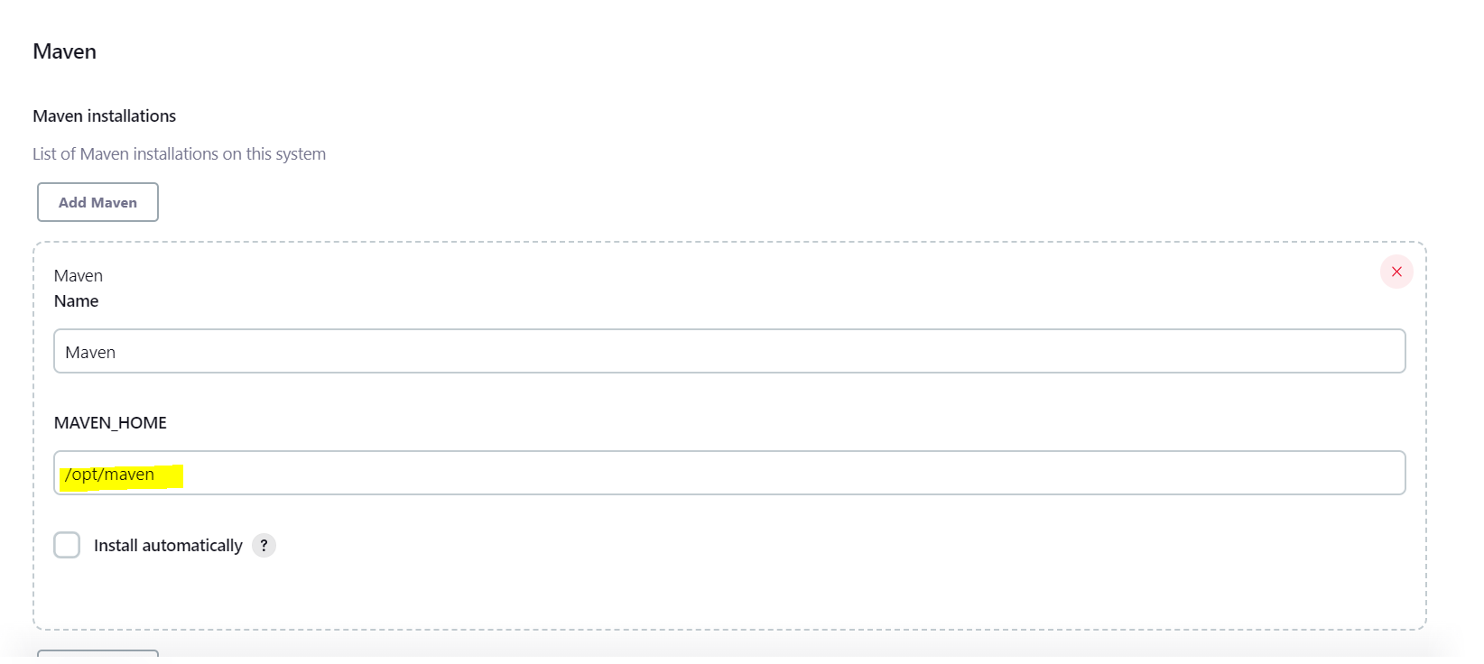

1. Create a Job to build the artifacts from the git code.

Dashboard 🡪 New Item 🡪 Give the Pipeline name (BuildOnlineBookStore)🡪 Choose Maven Project 🡪 Under SCM choose GIT and provide the GIT HTTPS url 🡪 Under Branches to Build give the Git Branch from which you want the code 🡪 Under Build give a clean install.

Once we configure the Pipeline, and trigger the build it will create a .war under the workspace /var/lib/Jenkins/workspace/BuildOnlineBookStore. We can use this .war to host the application

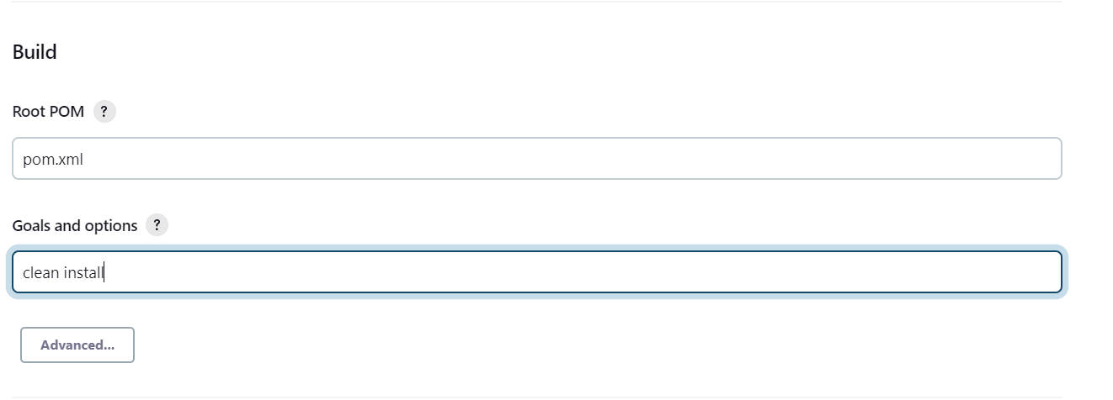

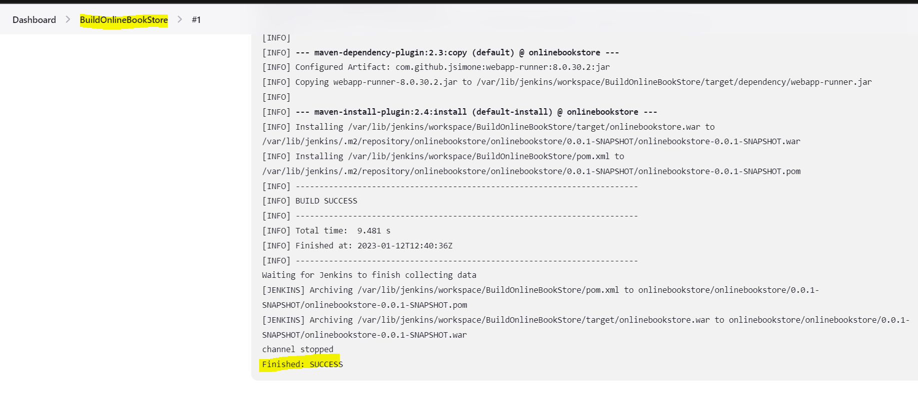

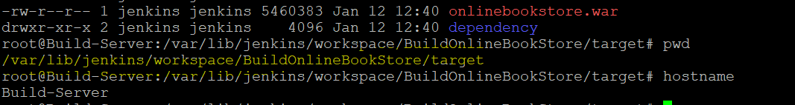

We can copy the onlinebookstore.war for build server to the tomcat-server and host our application. But we will integrate tomcat with Jenkins instead of copying manually every time whenever the code changes happen.

Code Update 🡪 GIT 🡪 Maven 🡪 Jenkins 🡪 Tomcat

***Deployment of the application with Jenkins:***

Prerequisite:

1. VM with tomcat
2. Deploy to container plugin in Jenkins

We have already installed Tomcat in the Azure VM, let’s integrate Jenkins and Tomcat.

1. Manage Jenkins 🡪 Manage Plugins 🡪Available (search for Deploy to container) 🡪 Install the plugin

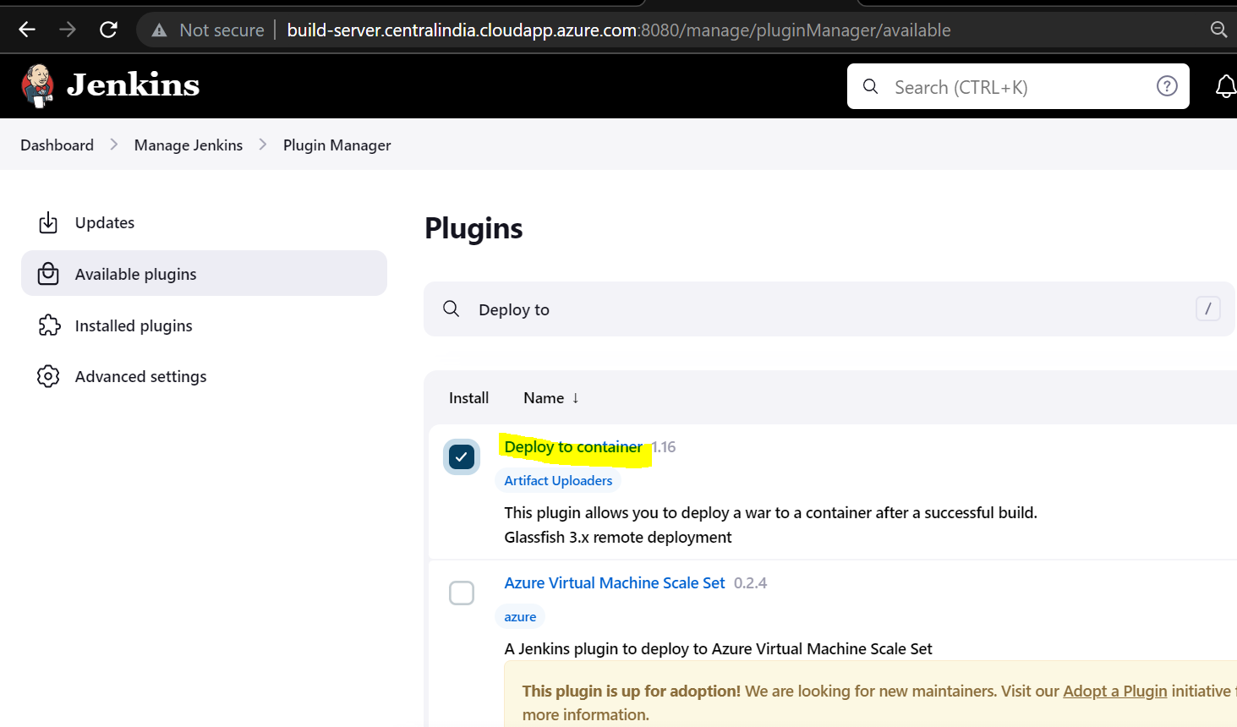

1. We must configure the credential for the tomcat deployments.
2. Create a job to deploy the war file in the tomcat server.

Dashboard 🡪 New Item 🡪 Give the Pipeline name (Deployment_Tomcat)🡪 Choose Maven Project 🡪 Under SCM choose GIT and provide the GIT HTTPS url 🡪 Under Branches to Build give the Git Branch from which you want the code 🡪 Under Build give a clean install 🡪 Under Post-build Actions choose Deploy war/ear to a container 🡪 Under container use tomcat creds and give the tomcat URL

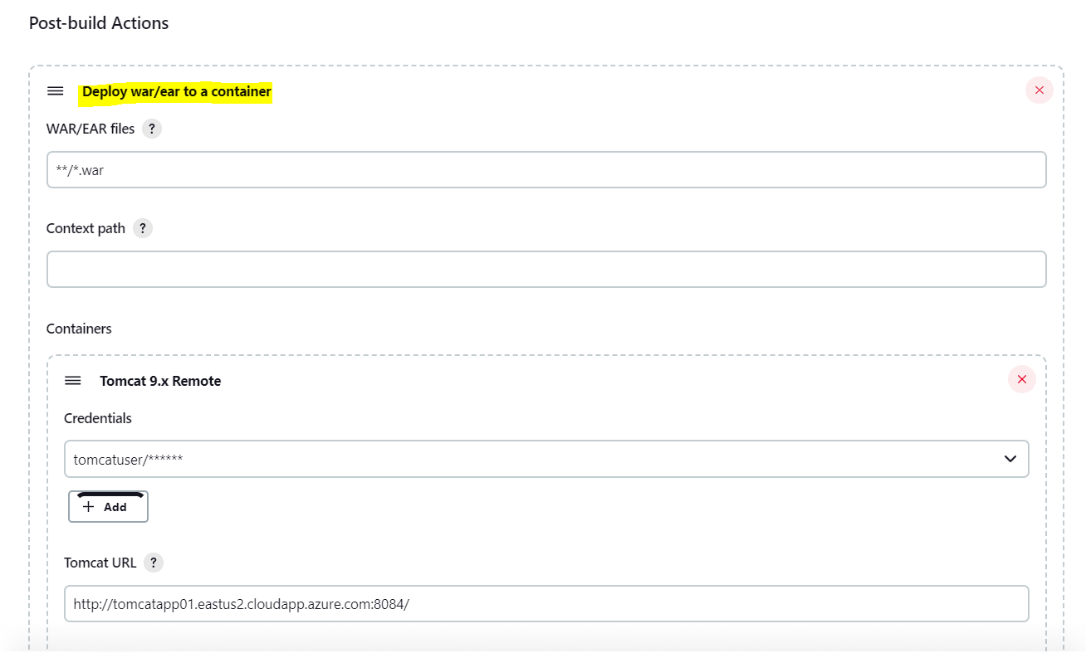

1. This Job will create the ear file and copy that into the tomcat server web apps location.
2. We can able to access the site <http://tomcatapp01.eastus2.cloudapp.azure.com:8084/>

***Dockers:***

We have used Tomcat in the traditional way, now we will create a customized tomcat image and connect it will our customized MySQL docker image to host our application.

**Prerequisite:**

1. Docker Hub account.
2. Knowledge of writing DockerFile
3. One Azure VM

**Steps to be Followed:**

1. In the Azure VM we must install docker, we have followed the instructions mentioned in tURL url

<https://docs.docker.com/engine/install/ubuntu/>

1. We have created a directory to create a Docker file.

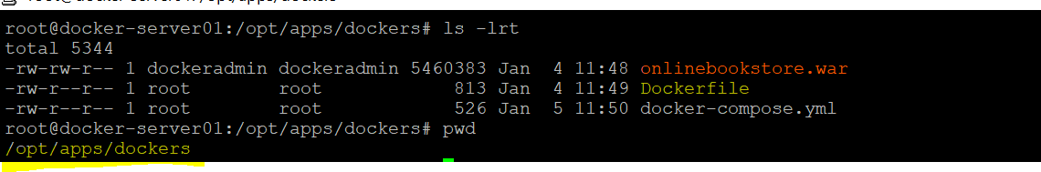

1. We have created a Jenkins Pipeline which will build the war file and copy it to the docker server.

<http://build-server.centralindia.cloudapp.azure.com:8080/job/DeploymentOnContainers/>

To create this pipeline, we must download the*Deploy to container plugin* and proceed with the configuration under Configuration System. Mention the SSH Server details (Docker server details/Private IP/username) click on advanced and give the password of your docker server.

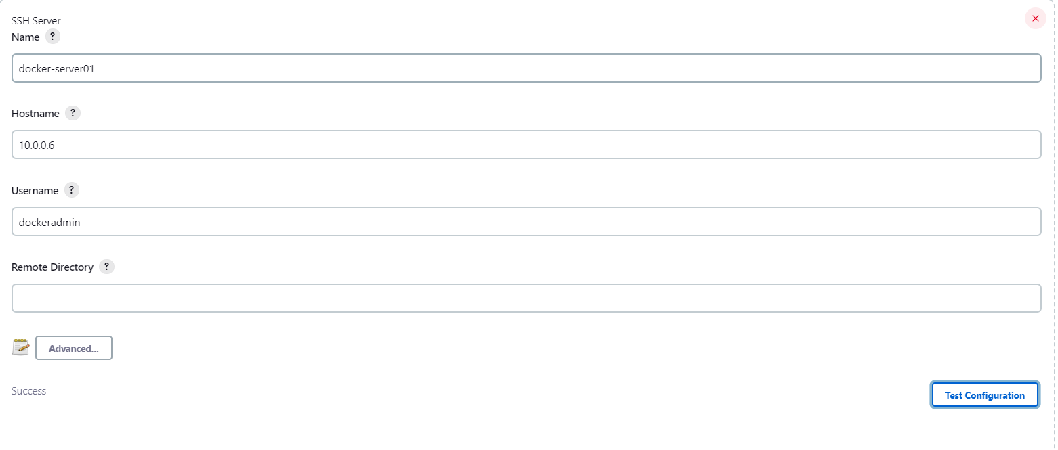

Post configuring create a new job and add git hub url. Under Post-Build Actions give the SSH Server details followed by the target path and war file and save the Job

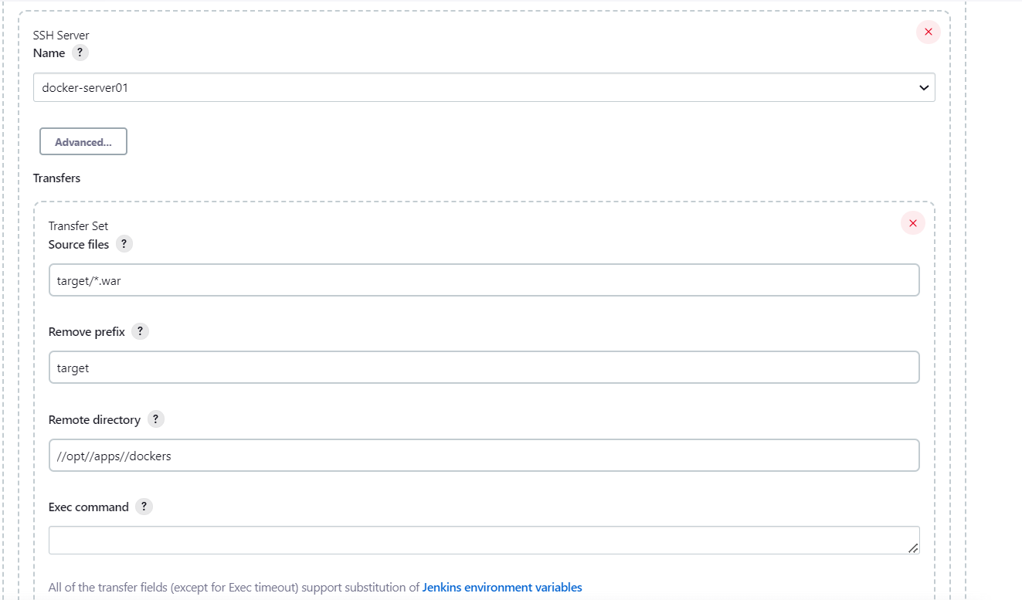

Once you trigger the build it will fetch the code from Git and build the code using maven and copy the .war file to docker-server.

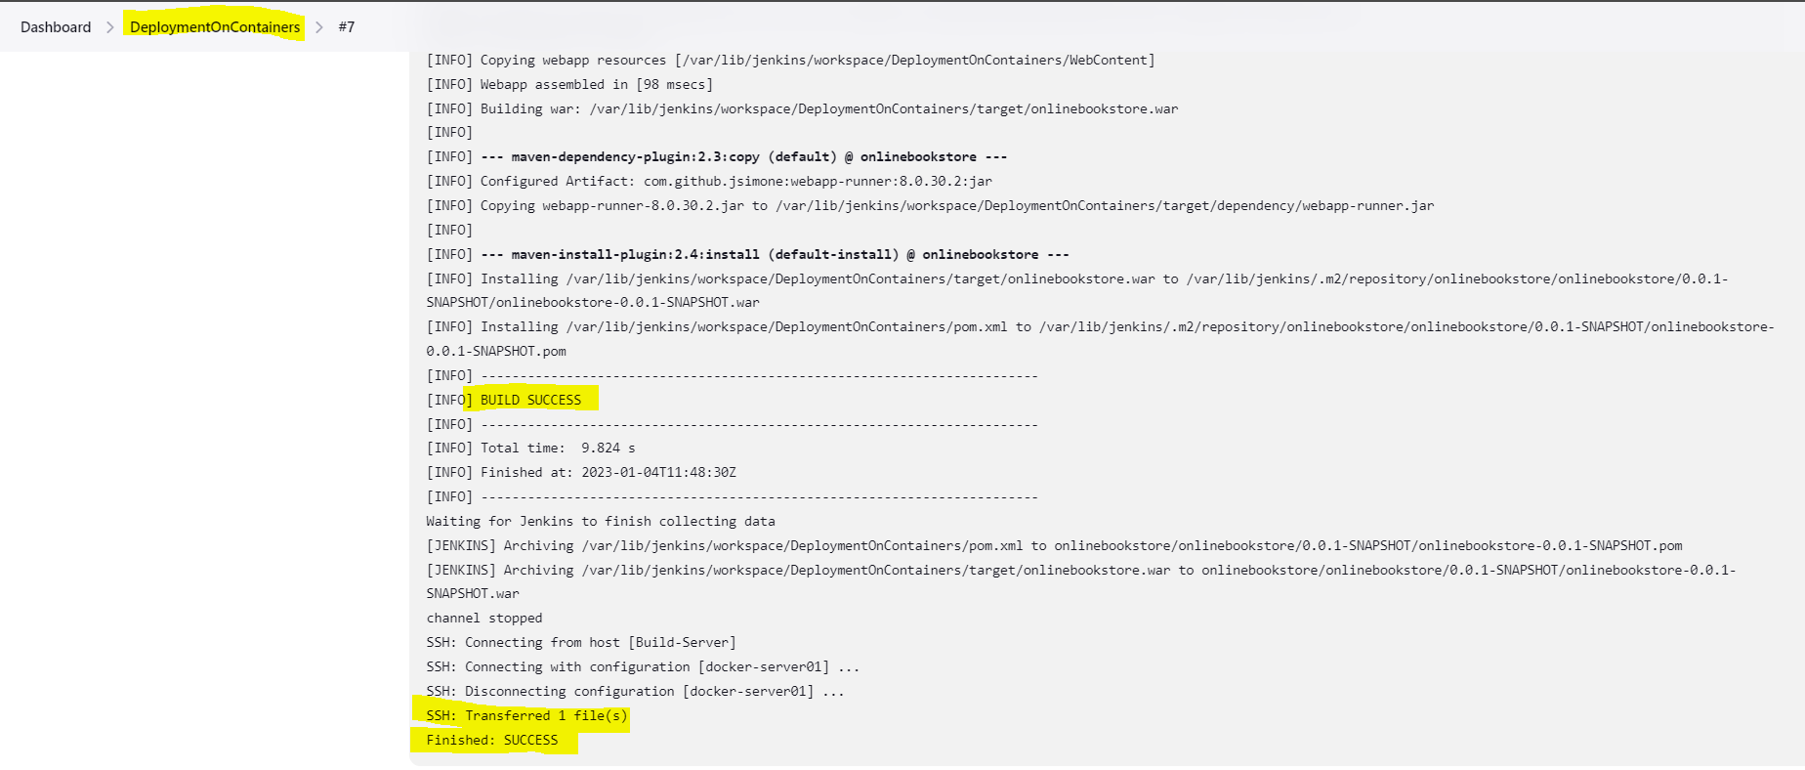

1. Create a Dockerfile to create a tomcat image.

|  |
| --- |
| FROM ubuntu  RUN apt-get update && apt-get install -y \  curl  CMD /bin/bash  RUN apt-get update && \  DEBIAN_FRONTEND=noninteractive \  apt-get -y install openjdk-11-jre-headless && \  apt-get clean && \  rm -rf /var/lib/apt/lists/*  MAINTAINER imala  RUN mkdir /opt/tomcat/  WORKDIR /opt/tomcat  RUN curl -O <https://downloads.apache.org/tomcat/tomcat-9/v9.0.70/bin/apache-tomcat-9.0.70.tar.gz>  RUN tar xvfz apache*.tar.gz  RUN mv apache-tomcat-9.0.70/* /opt/tomcat/.  WORKDIR /opt/apps/docker  COPY ./onlinebookstore.war /opt/tomcat/webapps  ENV db.driver=com.mysql.cj.jdbc.Driver db.host=jdbc:mysql://sql-container db.port=3307 db.name=onlinebookstore db.username=root db.password=root  EXPOSE 8080  CMD [“/opt/tomcat/bin/imalaa.sh”, “run”] |

FROM 🡪 For declaring a base image

MAINTAINER 🡪 Who created and

RUN 🡪 Commands to Run to make the image( the future container) in the way you want

EXPOSE 🡪 Do you want your image or application in the image to expose any port to the external world or at least to the host.  For example if you are building Apache HTTP server image you can EXPOSE port 80, In our case, it is 8080

CMD 🡪 The Default Command of the container which gets created using this image.

COPY 🡪 The files you want to copy into the container from your host.

WORKDIR 🡪 Define a workspace where the upcoming (or) following set of commands/instructions should be executed.

Note: We will discuss about ENV during DB installation

1. Once you created the Dockerfile, create an image using the below command

|  |
| --- |
| Cmd 🡪 docker build -t [Name Of the Image]  .  docker build -t onlinebookstore .  #To check the list of images  docker images  #To create a container from the docker images  docker run –name <containername> -p 8084:8080 -d <imagename>  #To check the list of running containers  docker ps    #To stop and start the container  docker stop/start <containername/id> |

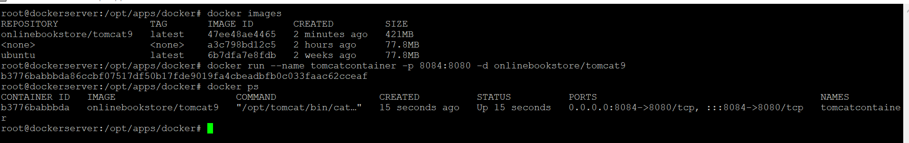

Now we can see the tomcat container is running on port 8084, we can be able to access the site now.

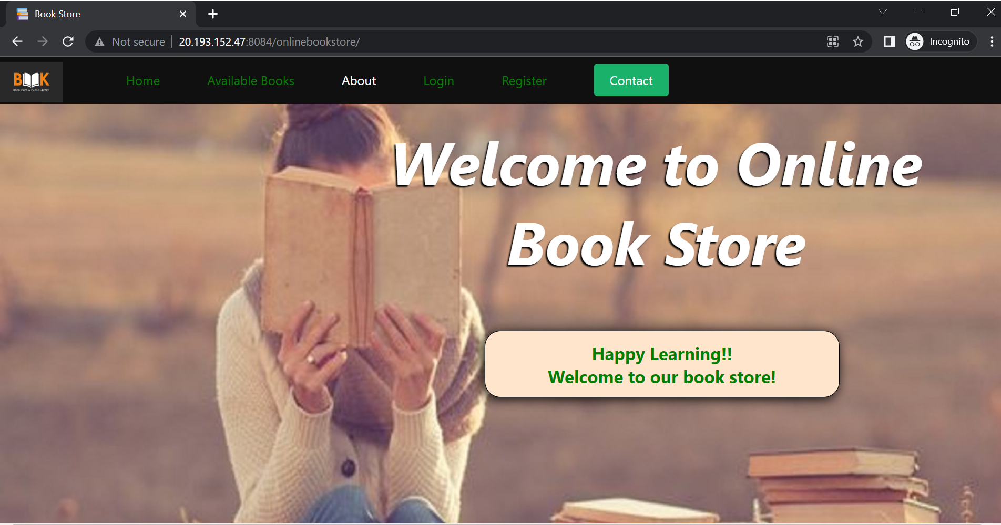

1. Now we can publish our tomcat image into our docker hub account and use this image by just using the docker pull command.

|  |
| --- |
| docker login #give docker hub creds  docker push <imagename>  #If you face any issue first tag the image and push it  docker tag <imagename> dockerid/imagename  docker tag onlinebookstore vimala77/onlinebookstore  docker push vimala77/onlinebookstore |

1. We can create a MySQL server as a database for our application. Write a Dockerfile to create a MySQL image.

|  |
| --- |
| FROM mysql  MAINTAINER imala  ENV MYSQL_ROOT_DATABASE onlinebookstore  COPY ./scripts/ /docker-entrypoint-initdb.d/ |

Under ENV we have mentioned the DATABASE name. We have copied the scripts to the /docker-entrypoint-initdb.d(which is the default storage location) which contains CreateDatastore.sql (queries to create the tables) and insert_table.sql(to insert the data).

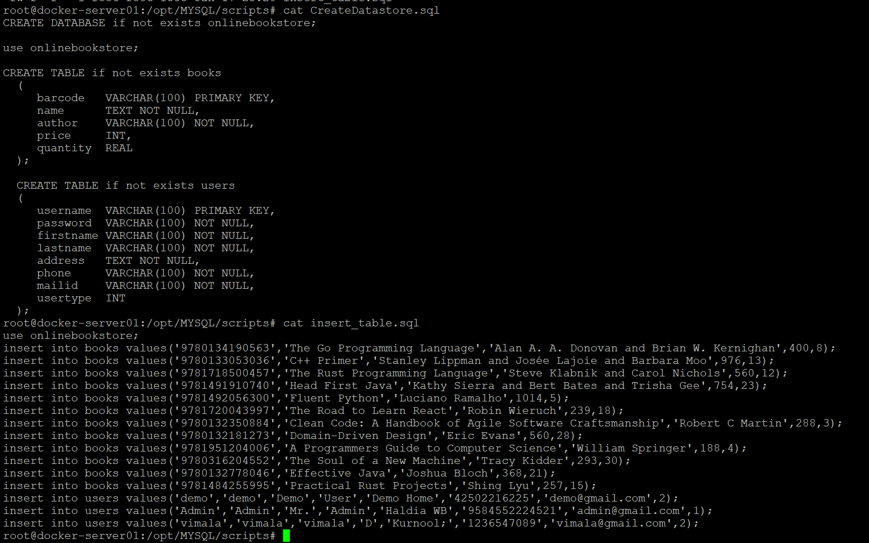

1. We also must mention the DB details in the tomcat Dockerfile where we have to give jdbc drivers, database name, port details, username, and password.

|  |
| --- |
| ENV db.driver=com.mysql.cj.jdbc.Driver db.host=jdbc:mysql://sql-container db.port=3307 db.name=onlinebookstore db.username=root db.password=root |

1. We can create a docker image from this Dockerfile, run and publish containers

|  |
| --- |
| docker build -t mycustom-mysql03 .  docker run –name sql-container -p 3307:3306 -e MYSQL_ROOT_PASSWORD=root -d mycustom-mysql03  docker login  docker tag mycustom-mysql03 vimala77/mycustom-mysql03  docker push vimala77/mycustom-mysql03 |

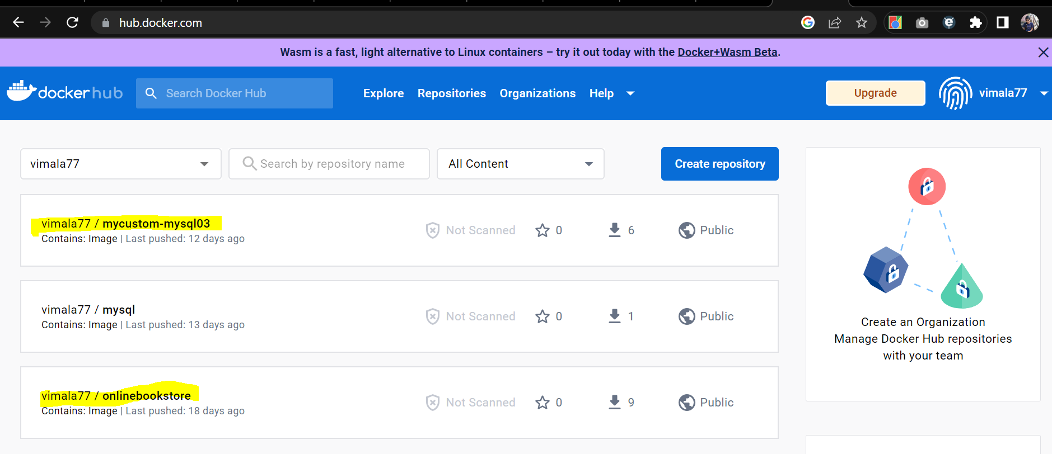

1. We can create a connection between tomcat and MySQL servers by using the link command.

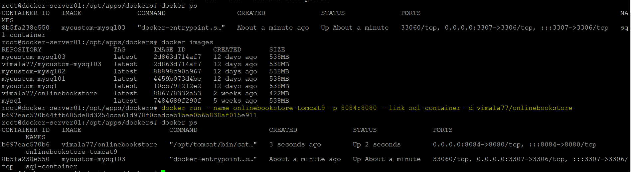

|  |
| --- |
| docker run –name <containername> -p 8084:8080 --link <db containername> -d <imagename> |

**Home Page:**



**Available Books Page (connecting to DB):**

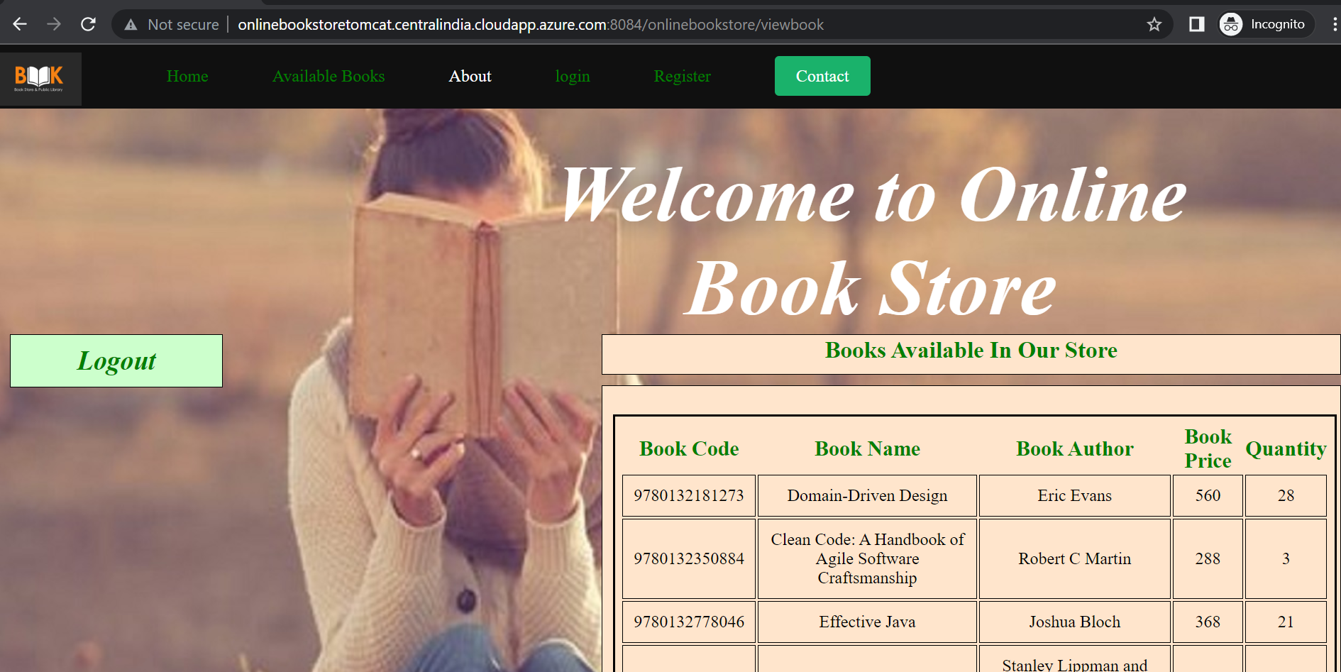

***Kubernetes for Container Orchestration:***

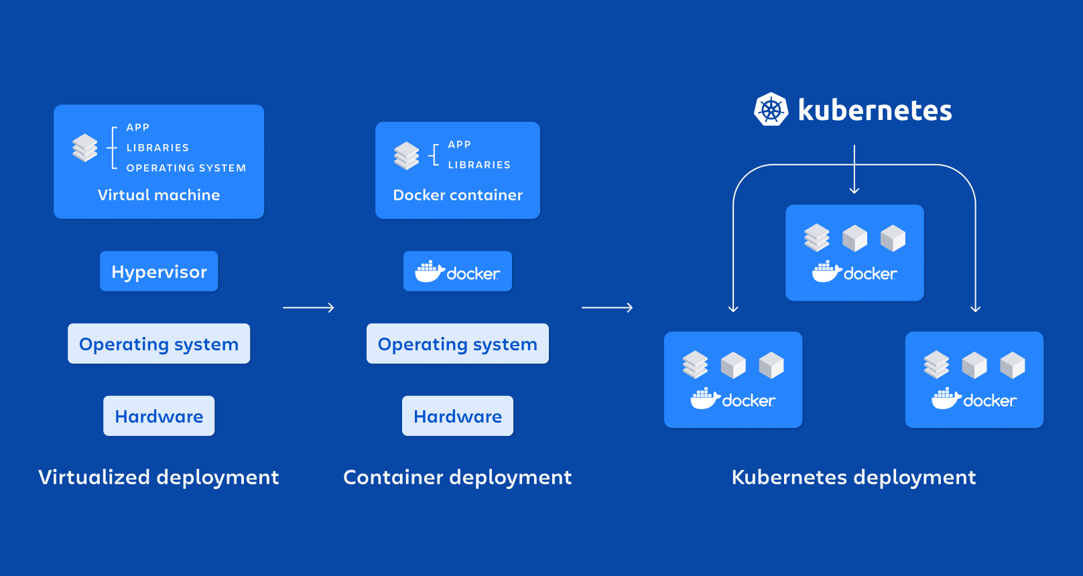

We have used Kubernetes to manage our containers, it provides high availability of containers/application and has a self-repairing capacity.

In this project, we have used Azure Kubernetes Services (AKS) for managing the container.

**Steps to be followed:**

1. Create an AKS cluster in the Azure portal. Follow the steps mentioned in this video <https://www.youtube.com/watch?v=NnwQZyi0BAs&t=1525s>
2. Once the cluster is created, we can connect using Azure cloud shell.

Kubernetes services 🡪 Choose the cluster 🡪 Click on Connect 🡪 Use the commands which are mentioned on the right side(both account set and credentials)

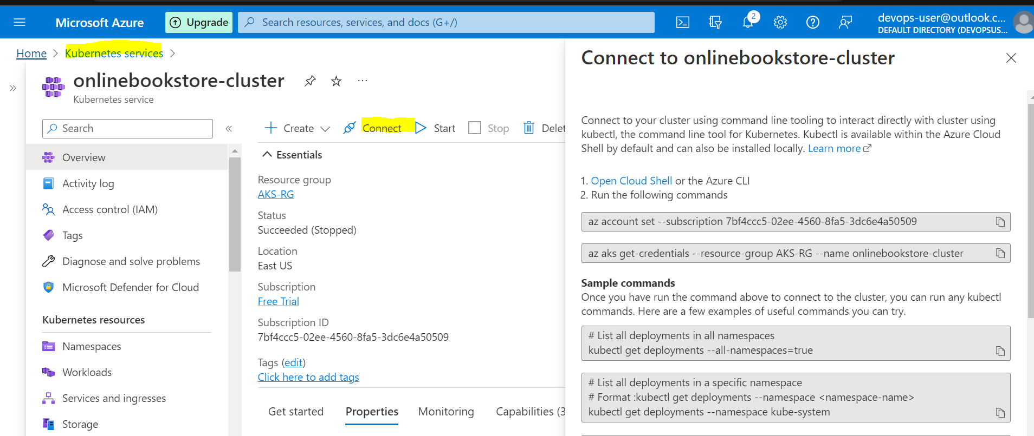

1. We can access the our Kubernetes cluster which we have created via cloud shell as below.

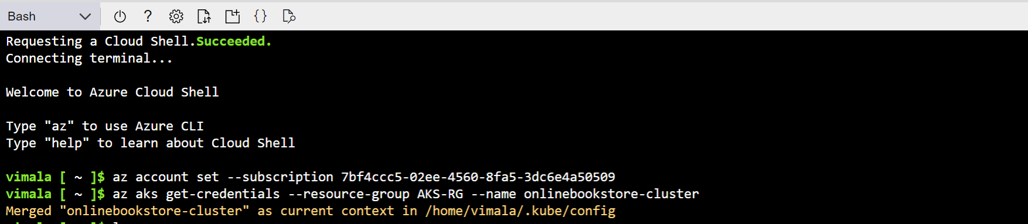

1. In Kubernetes we create containers by mentioning all the instructions in yaml file. We must create one deployment yaml (helps to create the container) and service yaml(helps to run the container).
2. In this project we have used three yaml files:-
3. tomcatapp.yml 🡪 To deploy the image and create the pods.
4. tomcatservices.yml 🡪 To manage the pods
5. onlinedb.yml 🡪 To deploy and manage the database pods

tomcatapp.yml

|  |
| --- |
| apiVersion: apps/v1  kind: Deployment  metadata:    name: onlinebookstore-tomcat9    labels:       app: onlinebookstore  spec:    replicas: 2    selector:      matchLabels:        app: onlinebookstore    template:      metadata:        labels:          app: onlinebookstore      spec:        containers:        - name: onlinebookstore-tomcat9          image: vimala77/onlinebookstore          imagePullPolicy: Always          env:          - name: DB_PORT_3306_TCP_ADDR            value: sql-container                #service name of mysql          - name: DB_ENV_MYSQL_PASSWORD            value: root          - name: DB_ENV_MYSQL_USER            value: root          - name: DB_ENV_MYSQL_DATABASE            value: sql-container          - name: DB_ENV_MYSQL_PASSWORD            value: root          ports:          - containerPort: 8080    strategy:      type: RollingUpdate      rollingUpdate:        maxSurge: 1        maxUnavailable: 1 |

tomcatservices.yml

|  |
| --- |
| apiVersion: v1  kind: Service  metadata:    name: onlinebookstore-service    labels:      app: onlinebookstore  spec:    selector:      app: onlinebookstore    ports:      - port: 8080        targetPort: 8080    type: LoadBalancer |

onlinedb.yml

|  |
| --- |
| apiVersion: v1  kind: Service  metadata:    name: sql-container  spec:    ports:    - port: 3306    selector:      app: sql-container    clusterIP: None  ---  apiVersion: apps/v1  kind: Deployment  metadata:    name: sql-container  spec:    selector:      matchLabels:        app: sql-container    strategy:      type: Recreate    template:      metadata:        labels:          app: sql-container      spec:        containers:        - image: vimala77/mycustom-mysql03          name: sql-container          env:          - name: MYSQL_ROOT_PASSWORD            value: root          ports:          - containerPort: 3306            name: sql-container          volumeMounts:          - name: mysql-persistent-storage            mountPath: /var/lib/mysql        volumes:        - name: mysql-persistent-storage          persistentVolumeClaim:            claimName: mysql-pv-claim |

1. Once we have all the yml files we can create pods and run our application, use below commands to work with kubernetes.

|  |
| --- |
| vimala [ ~ ]$ kubectl get all 🡪 To list all the deployments and services  NAME TYPE CLUSTER-IP EXTERNAL-IP PORT(S) AGE  service/kubernetes ClusterIP 10.0.0.1 <none> 443/TCP 15d  vimala [ ~ ]$ kubectl get pods 🡪 To list the running pods  No resources found in default namespace. |

1. As we can see currently we don’t have any deployments and no running pods. Let’s create the pods and run the application.

|  |
| --- |
| vimala [ ~ ]$ kubectl apply -f tomcatapp.yml 🡪 To deploy  Warning: spec.template.spec.containers[0].env[4].name: duplicate name "DB_ENV_MYSQL_PASSWORD"  deployment.apps/onlinebookstore-tomcat9 created  vimala [ ~ ]$ kubectl apply -f tomcatservices.yml  service/onlinebookstore-service created  vimala [ ~ ]$ kubectl get pods  NAME READY STATUS RESTARTS AGE  onlinebookstore-tomcat9-57f4fc8f6b-2czbq 1/1 Running 0 10s  onlinebookstore-tomcat9-57f4fc8f6b-n6rsq 1/1 Running 0 10s  vimala [ ~ ]$ kubectl get all  NAME READY STATUS RESTARTS AGE  pod/onlinebookstore-tomcat9-57f4fc8f6b-2czbq 1/1 Running 0 30s  pod/onlinebookstore-tomcat9-57f4fc8f6b-n6rsq 1/1 Running 0 30s  NAME TYPE CLUSTER-IP EXTERNAL-IP PORT(S) AGE  service/kubernetes ClusterIP 10.0.0.1 <none> 443/TCP 15d  service/onlinebookstore-service LoadBalancer 10.0.221.74 <pending> 8080:31192/TCP 13s  NAME READY UP-TO-DATE AVAILABLE AGE  deployment.apps/onlinebookstore-tomcat9 2/2 2 2 31s  NAME DESIRED CURRENT READY AGE  replicaset.apps/onlinebookstore-tomcat9-57f4fc8f6b 2 2 2 31s  vimala [ ~ ]$ kubectl get all  NAME READY STATUS RESTARTS AGE  pod/onlinebookstore-tomcat9-57f4fc8f6b-2czbq 1/1 Running 0 77s  pod/onlinebookstore-tomcat9-57f4fc8f6b-n6rsq 1/1 Running 0 77s  NAME TYPE CLUSTER-IP EXTERNAL-IP PORT(S) AGE  service/kubernetes ClusterIP 10.0.0.1 <none> 443/TCP 15d  service/onlinebookstore-service LoadBalancer 10.0.221.74 20.127.248.58 8080:31192/TCP 60s  NAME READY UP-TO-DATE AVAILABLE AGE  deployment.apps/onlinebookstore-tomcat9 2/2 2 2 78s  NAME DESIRED CURRENT READY AGE  replicaset.apps/onlinebookstore-tomcat9-57f4fc8f6b 2 2 2 78s |

1. We can use LoadBalancer External-IP to access the application.



1. We have to follow the same to do the db deployments. Post that we can able access DB as well.

kubectl apply -f onlinedb.yml

1. If in any case the pods are getting stopped or deleted then without any commands new pod will be generated to make the high availability of the application.

|  |
| --- |
| spec:    replicas: 2    selector:      matchLabels:        app: onlinebookstore |

***Azure Monitor as a Monitoring Tool:***

We have added the alerts for high CPU, disk, memory utilization, and application availability using Azure monitor.

CPU, disk, memory, network 🡪 VM Insights

Application Monitor (URL monitoring)🡪 Application Insights

Kubernetes Cluster Monitoring 🡪 Container Insights

We have used followed the below sources for adding monitor.

<https://learn.microsoft.com/en-us/azure/azure-monitor/overview>

<https://www.youtube.com/watch?v=YsmVxsqrXTk&t=145s>

<https://www.youtube.com/watch?v=NRWl7SxS5YE&t=15s>

Azure Monitor:

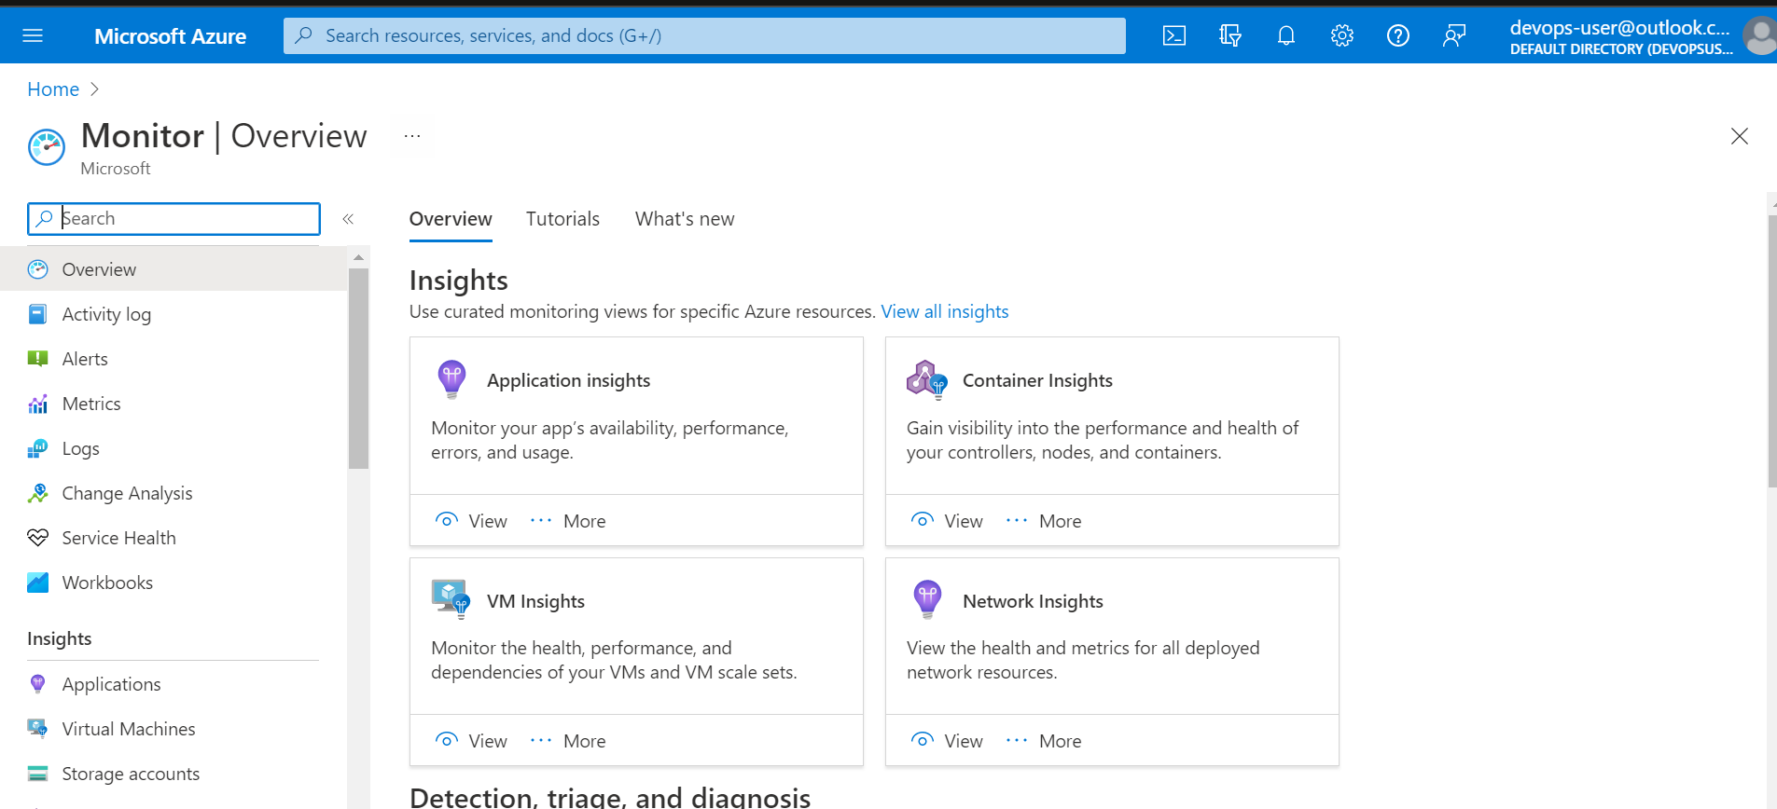

VM Insights:

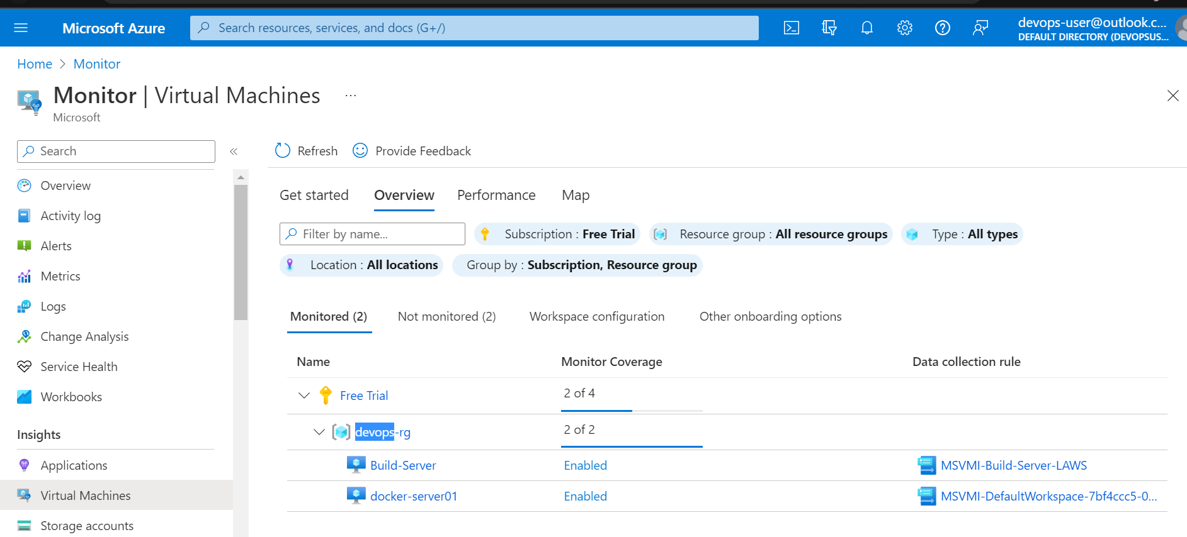

Mails alerts for CPU and Memory:

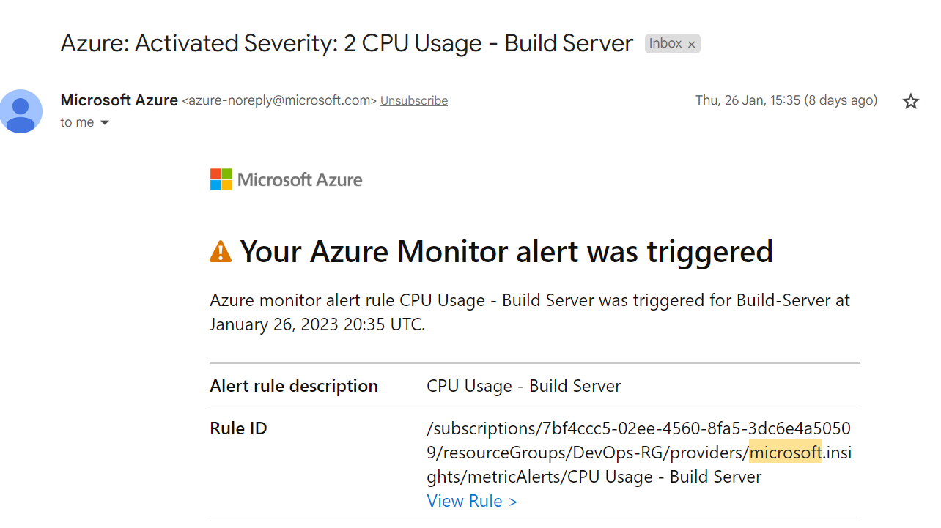

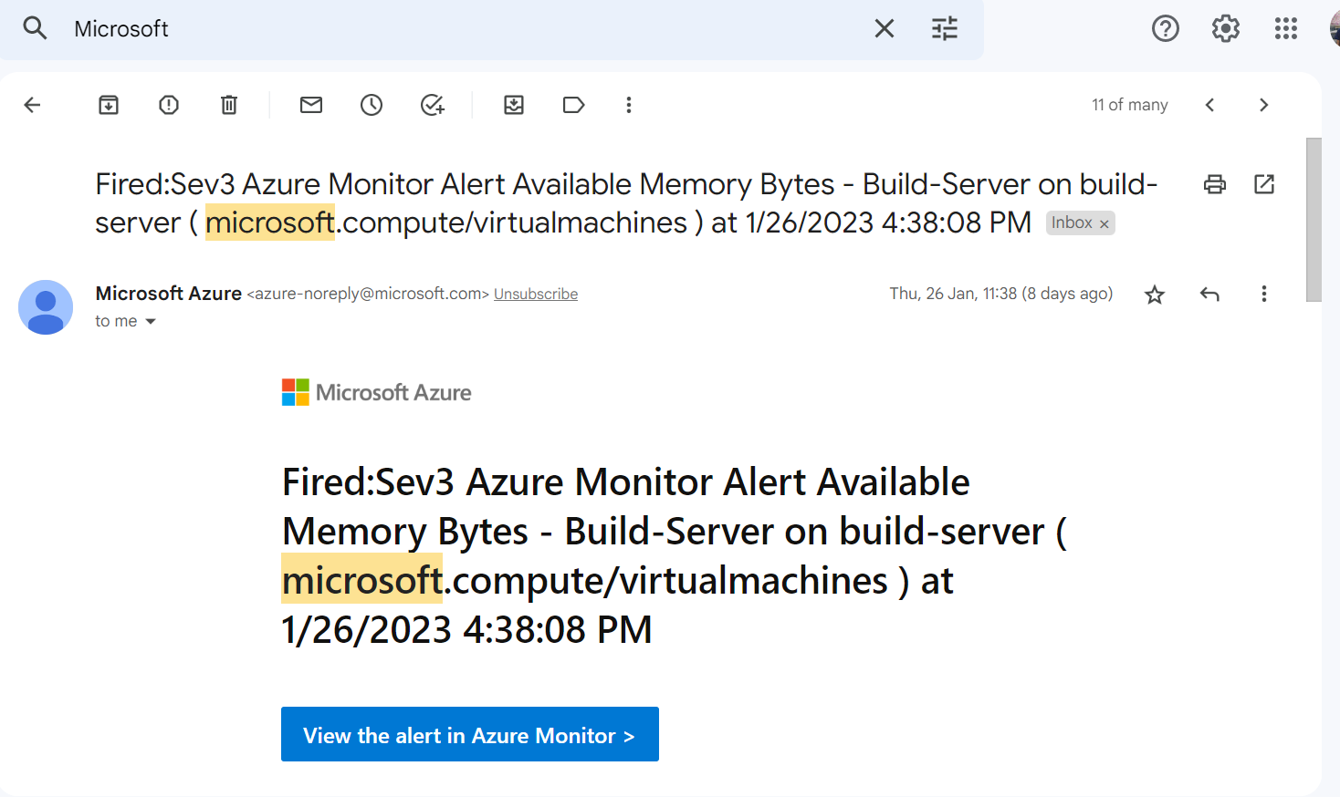

Application Insights:

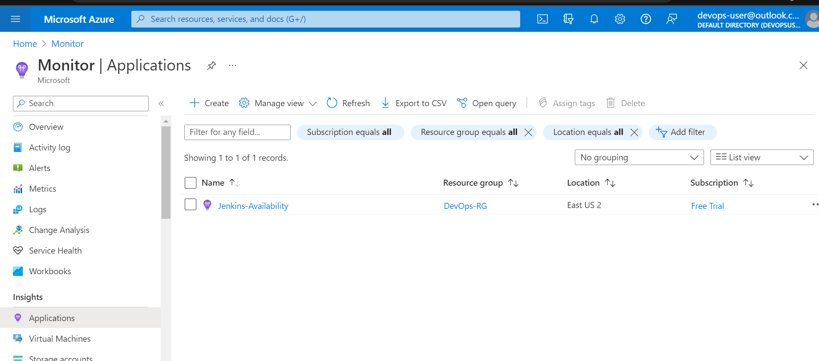

Container Insights:

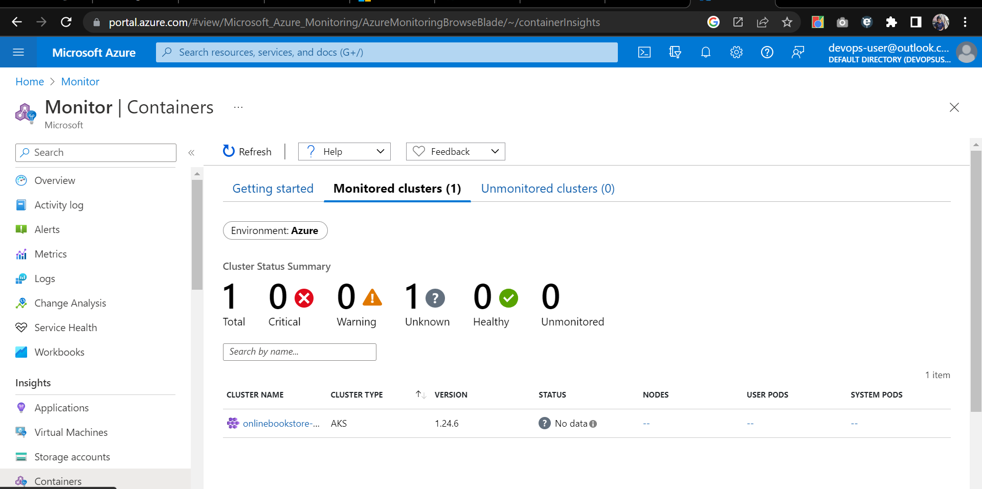

Kubernetes availability mail alerts:

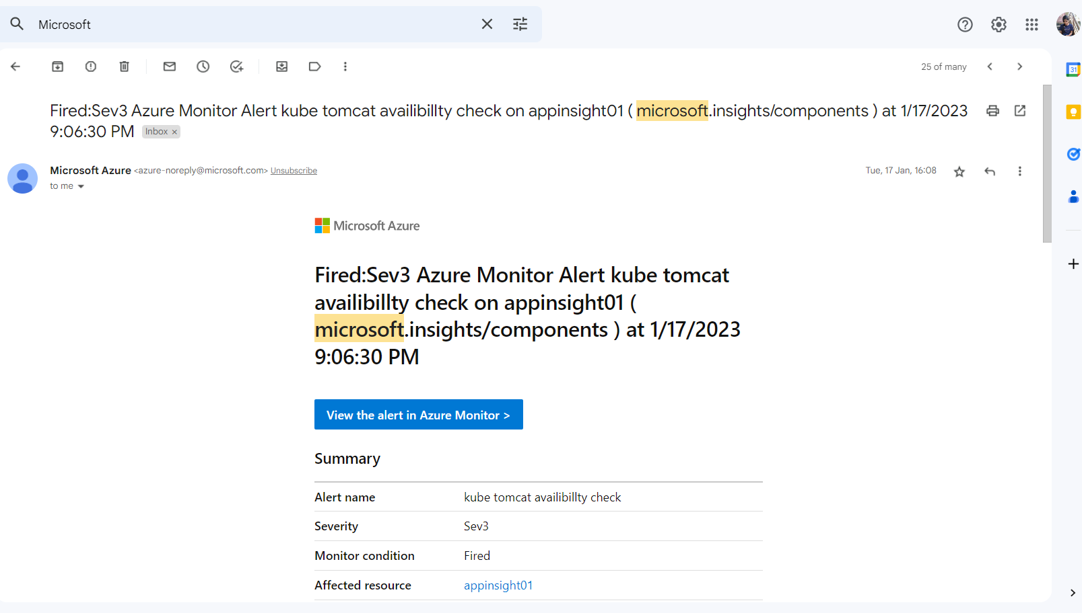

***Summary:***

In this project we have host onlinebookstore application in multiple ways. We have used devops tools

and dockers to host and automate the application.



For reverse proxy

[**https://www.howtoforge.com/how-to-install-apache-tomcat-9-on-debian-10/**](https://www.howtoforge.com/how-to-install-apache-tomcat-9-on-debian-10/)

**GIT Account:**

[**https://github.com/vimala-77/onlinebookstore**](https://github.com/vimala-77/onlinebookstore)

**Docker Hub account with customizes Images:**

**Tomcat:**

[**https://hub.docker.com/repository/docker/vimala77/onlinebookstore/general**](https://hub.docker.com/repository/docker/vimala77/onlinebookstore/general)

**DB:**

[**https://hub.docker.com/repository/docker/vimala77/mycustom-mysql03/general**](https://hub.docker.com/repository/docker/vimala77/mycustom-mysql03/general)

[**https://kubernetes.io/docs/tasks/run-application/run-single-instance-stateful-application/**](https://kubernetes.io/docs/tasks/run-application/run-single-instance-stateful-application/)

Container Registry:

Publishing an image to the Azure container registry:

1. Use AZ CLI

Install azure-cli <https://learn.microsoft.com/en-us/cli/azure/install-azure-cli-linux?pivots=apt>

1. Login to az -cli and login to the device

sudo az login

1. Login to container registry (u will get the username and password from access key)

Az acr login –name <name of container registry> --username <username> --password <pw>

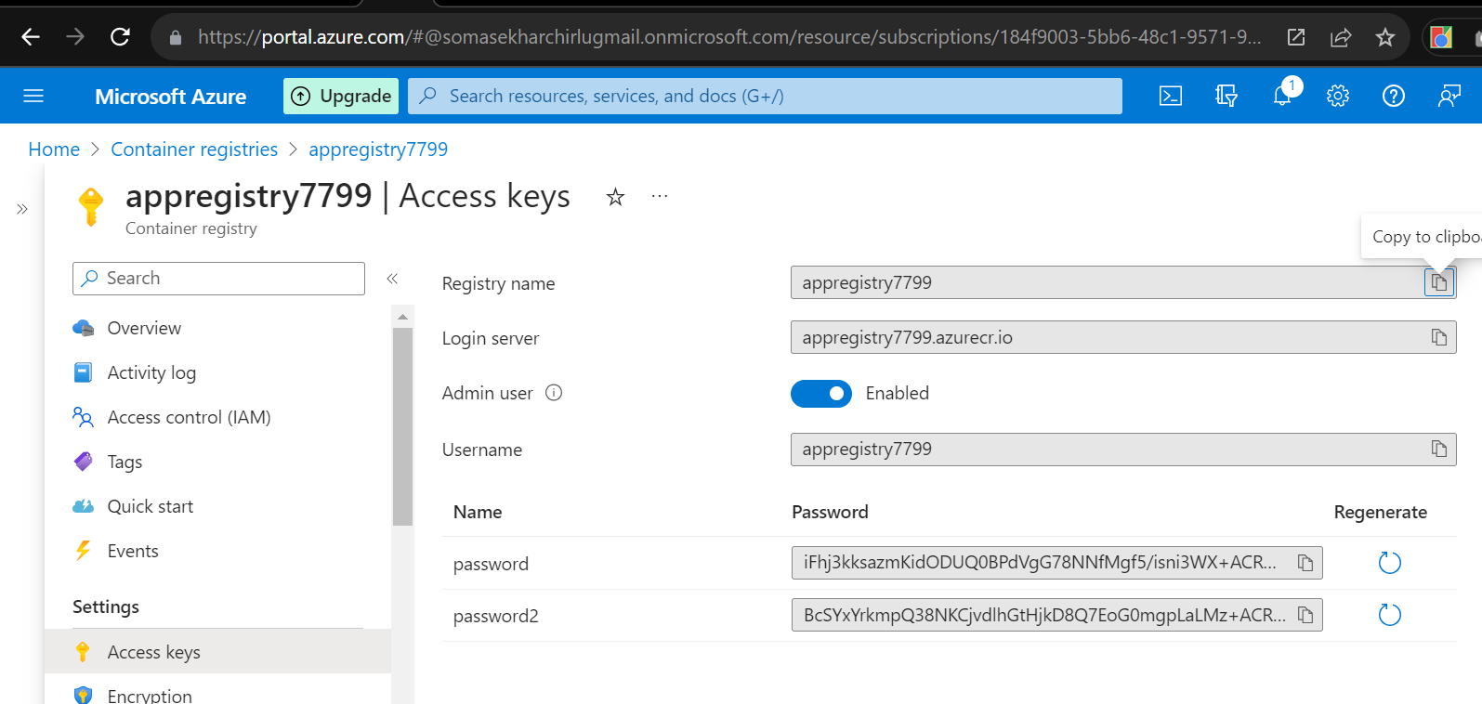

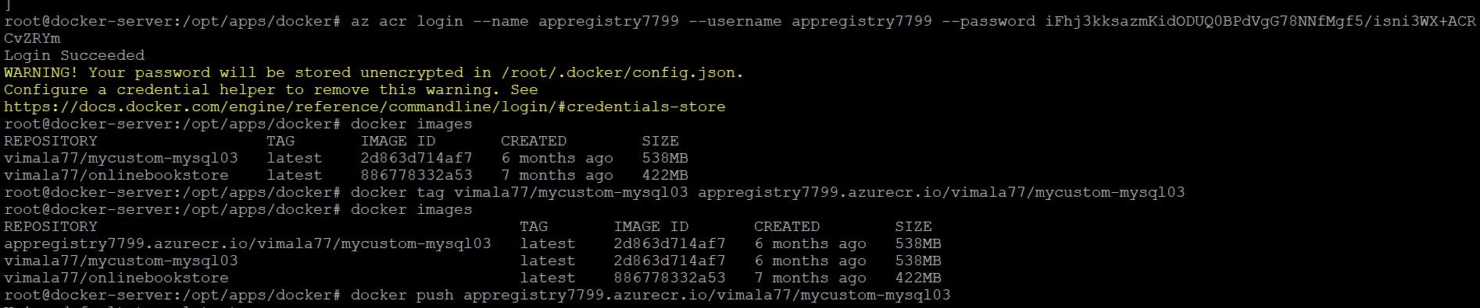

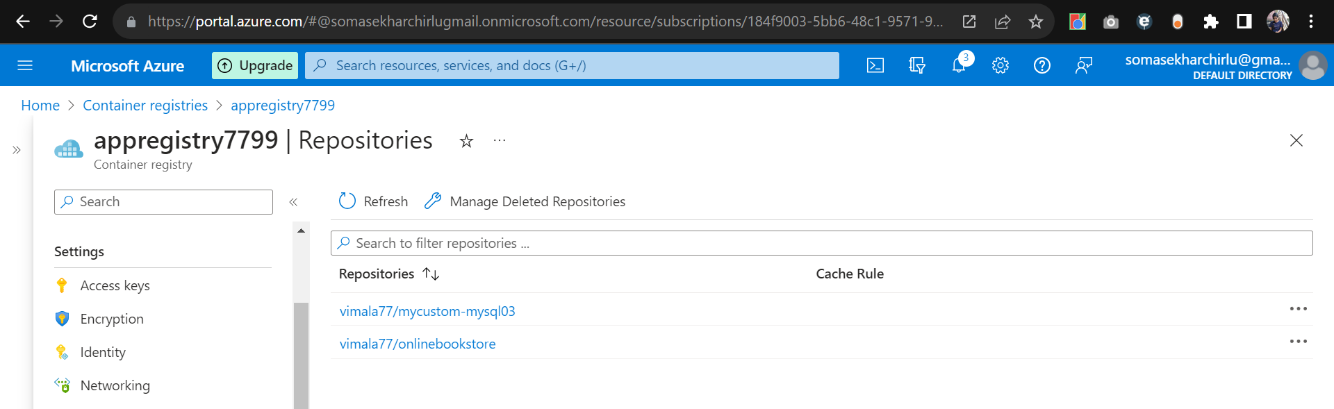

Azure Container instance service:

To run instances, PAAS 🡪 compute will be managed by azure